DEPARTMENT OF INFORMATION TECHNOLOGY

LAB RECORD

REGULATION 2022

Course Code : 23CS502
Name if the Course : Software Testing
Class : III IT
Semester : V
Academic Year : 2025-2026

DEPARTMENT OF INFORMATION TECHNOLOGY

23CS502 - SOFTWARE TESTING

CONTINOUS ASSESSMENT RECOED

Submitted by

Name: ……….…………………..……………..
Register No. : ………….……………….………
Degree & Branch: ………….………………..…
Class & Semester: ………….……………….…

DEPARTMENT OF INFORMATION TECHNOLOGY

23CS502 - SOFTWARE TESTING

Continous Assessment Recoed
Submitted by

Name : ……….…………………..…………… Register No : ……………………………...
Class/Semester : …………………………….. Degree & Branch : ………………………..

BONAFIDE CERTIFICATE
This is to certify that this record is the bonafide record of work done by Mr./Ms. _________________
during the academic year 2025 - 2026.

Faculty In-charge Head of the Department

Submitted for the University practical examination held on______________

INTERNAL EXAMINER EXTERNAL EXAMINER

PROGRAMME OUTCOMES:
Engineering Graduates will be able to:
● PO1. Engineering knowledge: Apply the knowledge of mathematics, science, engineering fundamentals, and an engineering specialization to the solution of complex engineering problems.
● PO2. Problem analysis: Identify, formulate, review research literature, and analyze complex engineering problems reaching substantiated conclusions using first principles of mathematics, natural sciences, and engineering sciences.
● PO3. Design/development of solutions: Design solutions for complex engineering problems and design system components or processes that meet the specified needs with appropriate consideration for the public health and safety, and the cultural, societal, and environmental considerations.
● PO4. Conduct investigations of complex problems: Use research-based knowledge and research methods including design of experiments, analysis and interpretation of data, and synthesis of the information to provide valid conclusions.
● PO5. Modern tool usage: Create, select, and apply appropriate techniques, resources, and modern engineering and IT tools including prediction and modeling to complex engineering activities with an understanding of the limitations.
● PO6. The engineer and society: Apply reasoning informed by the contextual knowledge to assess societal, health, safety, legal and cultural issues and the consequent responsibilities relevant to the professional engineering practice.
● PO7. Environment and sustainability: Understand the impact of the professional engineering solutions in societal and environmental contexts, and demonstrate the knowledge of, and need for sustainable development.
● PO8. Ethics: Apply ethical principles and commit to professional ethics and responsibilities and norms of the engineering practice.
● PO9. Individual and team work: Function effectively as an individual, and as a member or leader in diverse teams, and in multidisciplinary settings.
● PO10. Communication: Communicate effectively on complex engineering activities with the engineering community and with society at large, such as, being able to comprehend and write effective reports and design documentation, make effective presentations, and give and receive clear instructions.
● PO11. Project management and finance: Demonstrate knowledge and understanding of the engineering and management principles and apply these to one’s own work, as a member and leader in a team, to manage projects and in multidisciplinary environments.
● PO12. Life-long learning: Recognize the need for, and have the preparation and ability to engage in independent and life-long learning in the broadest context of technological change.

PROGRAMME EDUCATIONAL OBJECTIVES (PEO'S):
● PEO 1: Graduates will have a profound knowledge in the various programming languages and possess globally competent skill sets by inculcating continuous up gradation of their technical skills and personality traits.
● PEO 2: Graduates will be able to analyze and find solutions to various applications and reconcile the dynamic trends in the field of Information Technology.
● PEO 3: Graduates will contribute to the society by their ethical behavior and effective teamwork.
● PEO 4: Graduates will excel with different skills like effective communication, leadership qualities, and provide smart solutions in business environment.
PROGRAMME SPECIFIC OUTCOMES:
● PSO 1: Graduates will demonstrate multidisciplinary knowledge for problem solving by creating solutions for product based and application-based software for the advancement of the society.
● PSO 2: Graduates attain advance knowledge in Information and Communication Technologies (ICT) thereby creating real time solutions for different projects by using modern tools prevailing in the current trends.
● PSO 3: Graduates will exhibit state of the art technologies by applying their knowledge in various programming skills to overcome the demand of sustainable development.
COURSE OBJECTIVES
● To provide students with an understanding of core testing concept To learn the functional and non-functional testing
● To understand the different types of user acceptance testing and end-to-end testing
● To get familiarize with the best practices of testing
COURSE OUTCOMES
Plan and apply the appropriate level of testing within the context of a software development application to the satisfaction of its beneficiaries .Analyze specific and measurable test cases to ensure coverage and traceability to requirements.
Understand the problem of reporting techniques, metrics, and testing status reports and communicate testing results to colleagues, managers, and end users .
Apply testing models, processes and practices appropriate for the software development lifecycle model of a project. Apply principles and practices of test-driven development to improve testing quality and reduce delivery times .
Inspect the various testing processes towards the continuous delivery of a software product .

REFERENCES RUBRICS TABLE
Criteria | Range of Marks
Criteria | Excellent | Good | Average | Below Average
Aim & Algorithm(20 marks) | 19-20 | 17-18 | 15-16 | 0-14
Program with Proper Syntax and Structure (30 Marks) | 27-30 | 21-26 | 15-20 | 1-14
Compilation and Debugging(30 marks) | 27-30 | 21-26 | 15-20 | 0-14
Documentation  (10 Marks) | 9-10 | 7-8 | 5-6 | 0-4
Viva  (10 Marks) | 9-10 | 7-8 | 5-6 | 0-4
Overall Marks | 90-100 | 70-89 | 50-69 | 0-49

Components | EX1 | EX2 | EX3 | EX4 | EX5 | EX6 | EX7 | EX8 | EX9 | EX10 | EX11
Aim & Algorithm (20 marks)
Program with Proper
Syntax and Structure (30 Marks)
Compilation and Debugging
(30 Marks)
Documentation (10 Marks)
Viva
(10 Marks)
TOTAL
Consolidated Mark (100)
Faculty Signature

TABLE OF CONTENTS

S.NO | NAME OF THE EXPERIMENT | PAGE NO
1. | Develop a program to automate the login process for a specified webpage using Selenium.
2. | Write an automation script using Selenium to handle form elements on a given website.
3. | Create an automation script with Selenium to interact with specific web elements on a designated webpage.
4. | Implement automation scripts using TestNG, prioritizing different test cases for efficient testing on a given website.
5. | Develop automation scripts with TestNG, incorporating seven levels of logging for detailed analysis while testing a specified website.
6. | Execute application tests using designed test cases and generate an HTML  report for a comprehensive overview.
7. | Design and implement a hybrid framework for a ticket booking system, along with associated test cases.
8. | Develop a hybrid framework and associated test cases for a hotel room booking system.
9. | Design and develop a hybrid framework and relevant test cases for a hospital appointment application.
10. | Implement a hybrid framework and associated test cases for an e-commerce application.
11. | Develop a hybrid framework and design test cases for comprehensive testing of an insurance website.

Ex.No:1 | DEVELOP A PROGRAM TO AUTOMATE THE LOGIN PROCESS FOR A SPECIFIED WEBPAGE USING SELENIUM.

AIM:
To develop a program using Selenium WebDriver that automates the login process for a
specified webpage by interacting with its input fields and buttons.

DESCRIPTION:
This program demonstrates the use of Selenium WebDriver to automate web interactions.
The process involves opening the target webpage in a browser, locating the username and
password input fields, entering the login credentials, and submitting the form. The
implementation covers identifying web elements using locators (such as ID, name, XPath, or
CSS selectors), performing user-like actions, and optionally validating the success of the login
process. This automation approach is useful for repetitive login testing, data validation, and
improving efficiency in web-based workflows.

CODE:

<dependency>
<groupId>org.seleniumhq.selenium</groupId>
<artifactId>selenium-java</artifactId>
<version>4.33.0</version>
</dependency>

import org.openqa.selenium.By;
import org.openqa.selenium.WebDriver;
import org.openqa.selenium.WebElement;
import org.openqa.selenium.chrome.ChromeDriver;
public class LoginAutomation {

public static void main(String[] args) {

WebDriver driver = new ChromeDriver();
driver.get("https://practicetestautomation.com/practice-test-login/");
driver.manage().window().maximize();

WebElement username = driver.findElement(By.id("username"));
username.sendKeys("student");
WebElement password = driver.findElement(By.id("password"));
password.sendKeys("Password123");
WebElement loginButton = driver.findElement(By.id("submit"));
loginButton.click();
System.out.println("Page Title : " + driver.getTitle());
driver.quit();
}
}

OUTPUT:

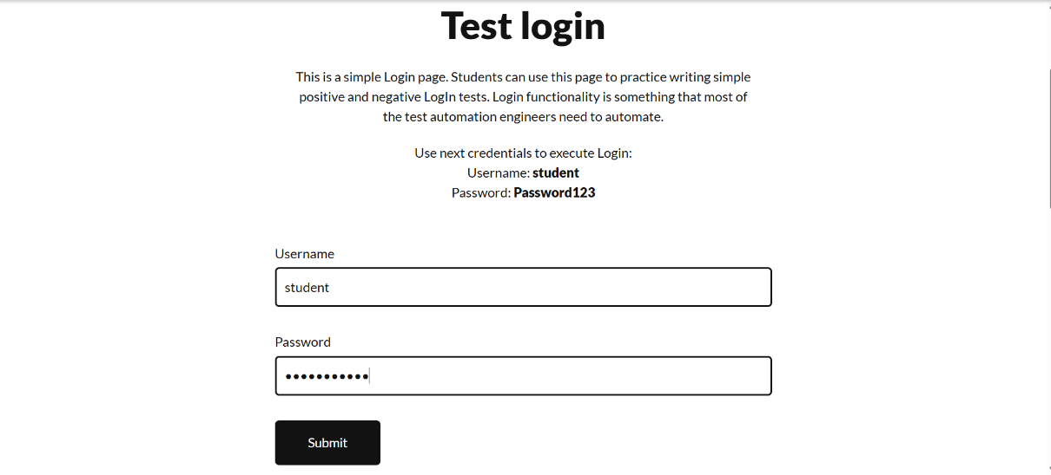
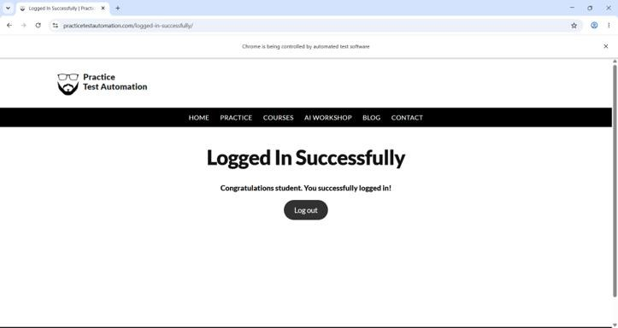

RESULT :
Thus the program is developed using Selenium WebDriver that automates the login
process for a specified webpage by interacting with its input fields and buttons.
Ex.No:2 | WRITE AN AUTOMATION SCRIPT USING SELENIUM TO HANDLE FORM ELEMENTS ON A GIVEN WEBSITE.

AIM:
To develop an automation script using Selenium that fills and submits a web form by
interacting with various form elements such as text fields, radio buttons, checkboxes, and drop-
down menus.

DESCRIPTION:
Selenium is an automation testing framework that allows us to interact with web
applications programmatically.
This program will:
• Open a specified webpage.
• Locate form elements using locators (ID, name, XPath, etc.).
• Enter data into input fields.
• Select options from dropdowns.
• Check/uncheck checkboxes.
• Submit the form.
• Display a success message.

CODE:
<dependency>
<groupId>org.seleniumhq.selenium</groupId>
<artifactId>selenium-java</artifactId>
<version>4.33.0</version>
</dependency>

import org.openqa.selenium.By;
import org.openqa.selenium.Keys;
import org.openqa.selenium.WebDriver;
import org.openqa.selenium.chrome.ChromeDriver;
public class FormAutomation {
public static void main(String[] args) throws InterruptedException {
WebDriver driver = new ChromeDriver();
driver.manage().window().maximize();
driver.get("https://demoqa.com/automation-practice-form");
driver.findElement(By.id("firstName")).sendKeys("PRANITH");
driver.findElement(By.id("lastName")).sendKeys("S");
driver.findElement(By.id("userEmail")).sendKeys("727724euit178@skcet.ac.in");
driver.findElement(By.xpath("//label[text()='Male]")).click();
driver.findElement(By.id("userNumber")).sendKeys("9344829607");
driver.findElement(By.xpath("//label[text()='Sports']")).click();
driver.findElement(By.id("currentAddress")).sendKeys("Coimbatore, TamilNadu");
driver.findElement(By.id("uploadPicture"))
.sendKeys("C:\\Users\\gurup\\Downloads\\WhatsApp Image 2026-06-15 at 8.59.21 AM.jpeg");
Thread.sleep(2000);
driver.findElement(By.tagName("body")).sendKeys(Keys.END);
Thread.sleep(1000);
driver.findElement(By.id("submit")).sendKeys(Keys.ENTER);
Thread.sleep(5000);
driver.quit();
}
}

OUTPUT:
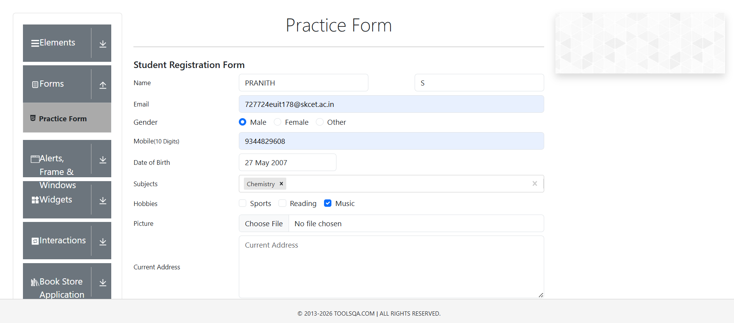

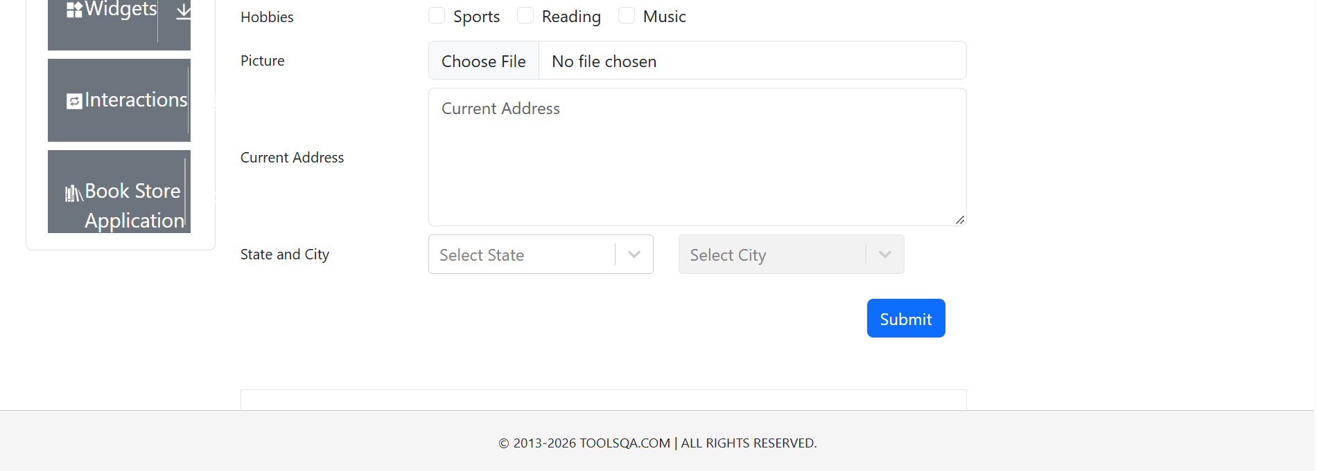

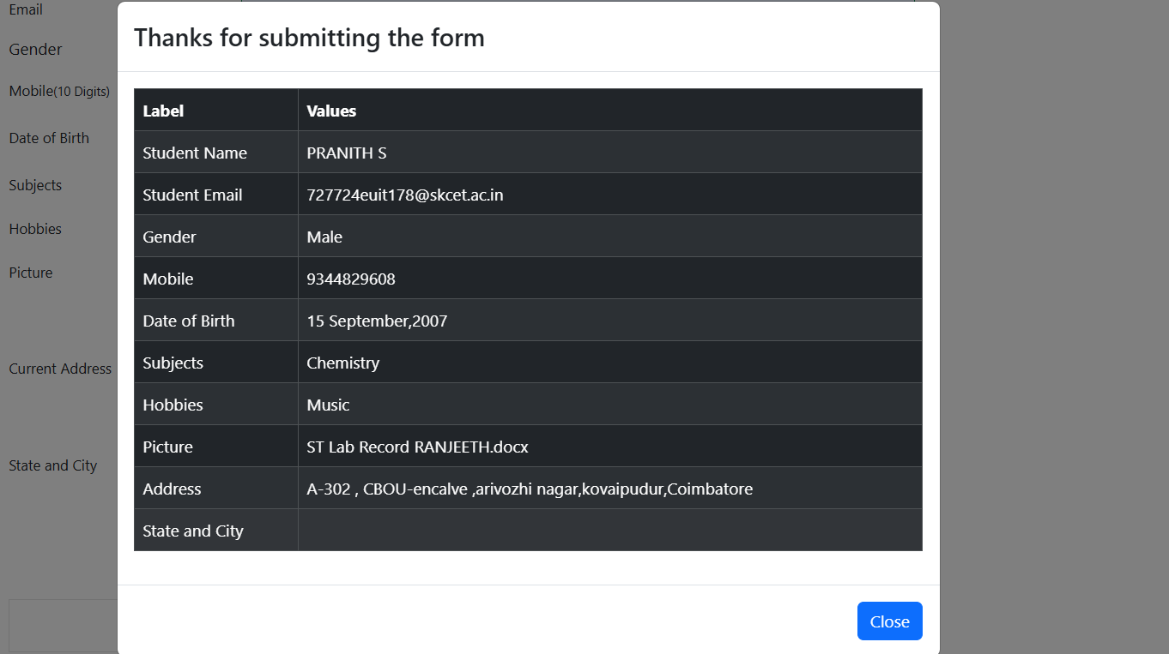

RESULT :
Thus, the code is successfully automated filling out a form and submitting it using Java +
Selenium WebDriver.

Ex.No:3 | CREATE AN AUTOMATION SCRIPT WITH SELENIUM TO INTERACT WITH SPECIFIC WEB ELEMENTS ON A DESIGNATED WEBPAGE.

AIM:
To automate navigation and interaction with specific elements on the Angi website
using Selenium WebDriver in Java, following the given test steps.

DESCRIPTION:
This automation script will:
1. Launch the Chrome browser and navigate to
https://demoqa.com/automation-practice-form
2. Click on "Articles G Advice" from the navigation menu.
3. Select "Outdoor Living" from the dropdown menu.
4. Scroll down to the footer and click on "Show More" to load more articles.
5. Ǫuit the browser session after execution.
The script uses Selenium WebDriver, ChromeDriver, and explicit waits
to handle dynamic page loads.

CODE:

<dependency>
<groupId>org.seleniumhq.selenium</groupId>
<artifactId>selenium-java</artifactId>
<version>4.33.0</version>
</dependency>

import org.openqa.selenium.By;
import org.openqa.selenium.Keys;
import org.openqa.selenium.WebDriver;
import org.openqa.selenium.chrome.ChromeDriver;
public class FormAutomation {
public static void main(String[] args) throws InterruptedException {

WebDriver driver = new ChromeDriver();
driver.manage().window().maximize();
driver.get("https://demoqa.com/automation-practice-form");
driver.findElement(By.id("firstName")).sendKeys("PRANITH ");
driver.findElement(By.id("lastName")).sendKeys("S");
driver.findElement(By.id("userEmail")).sendKeys("727724euit178@skcet.ac.in");
driver.findElement(By.xpath("//label[text()='Male']")).click();
driver.findElement(By.id("userNumber")).sendKeys("9344829608");
driver.findElement(By.xpath("//label[text()='Music']")).click();
driver.findElement(By.id("currentAddress")).sendKeys("Bangalore, Karnataka");
driver.findElement(By.id("uploadPicture"))
.sendKeys("C:\\Users\\gurup\\Downloads\\WhatsApp Image 2026-06-15 at 8.59.21 AM.jpeg");
Thread.sleep(2000);
driver.findElement(By.tagName("body")).sendKeys(Keys.END);
Thread.sleep(1000);
driver.findElement(By.id("submit")).sendKeys(Keys.ENTER);
Thread.sleep(5000);
driver.quit();
}
}

OUTPUT:

RESULT :
The script ran successfully, performed all the required actions on the website, and closed
the browser without errors.
Ex.No:4 | IMPLEMENT AUTOMATION SCRIPTS USING TESTNG, PRIORITIZING DIFFERENT TEST CASES FOR EFFICIENT TESTING ON A GIVEN WEBSITE.

AIM:
To automate login functionality and navigation on a website using Selenium WebDriver
with TestNG, assigning priorities to test cases for efficient execution.

DESCRIPTION:
In this automation project, we will:
1. Create a Maven project with Selenium and TestNG dependencies.
2. Launch the OrangeHRM login page.
3. Enter username and password.
4. Click on the login button.
5. Navigate to the "My Info" section after login.
6. Use TestNG @Test(priority = n) to define execution order.

CODE:
pom.xml dependencies:
<dependency>
<groupId>org.seleniumhq.selenium</groupId>
<artifactId>selenium-firefox-driver</artifactId>
<version>4.33.0</version>
</dependency>
<dependency>
<groupId>org.testng</groupId>
<artifactId>testng</artifactId>
<version>7.11.0</version>
</dependency>
import org.testng.Assert;
import org.testng.annotations.Test;
public class CalculatorTest {
// 1. First Priority Test Case
@Test(priority = 1)
public void testAddition() {
int result = 5 + 5;
// Validating expected output vs actual calculation
Assert.assertEquals(result, 10);
System.out.println("Addition Test Passed");
}
// 2. Second Priority Test Case
@Test(priority = 2)
public void testSubtraction() {
int result = 54 - 27;
Assert.assertEquals(result, 27);
System.out.println("Subtraction Test Passed");
}
}
OUTPUT:
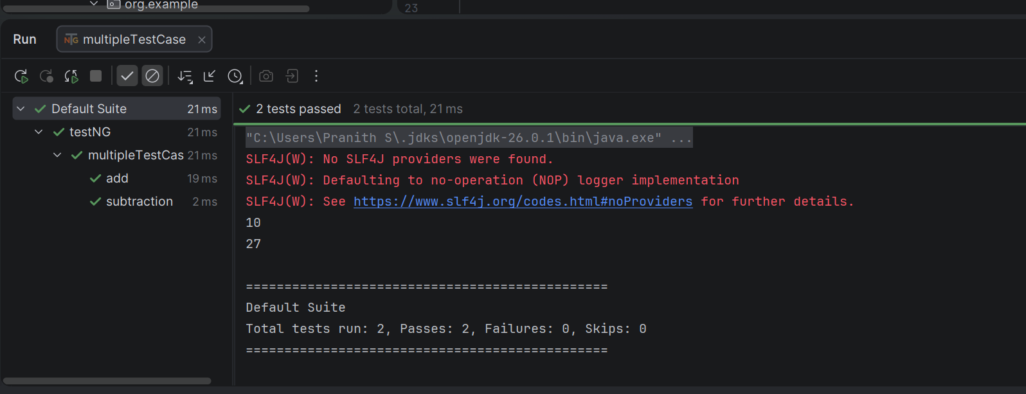
RESULT :
The TestNG automation framework successfully launched the SpiceJet homepage,
captured a screenshot stored in 'Project/screenshots', and generated an Extent Report in
'Project/reports'.
Ex.No:5 | DEVELOP AUTOMATION SCRIPTS WITH TESTNG, INCORPORATING SEVEN LEVELS OF LOGGING FOR DETAILED ANALYSIS WHILE TESTING A SPECIFIED WEBSITE.

AIM:
To design and implement an automated testing framework using Java, Selenium,
TestNG, and Log4j to test a specified website, while incorporating seven logging levels for
detailed execution tracking and debugging.

DESCRIPTION:
In software test automation, logging is essential to capture detailed execution flow,
issues, and environment details. This project implements seven levels of logging (TRACE,
DEBUG, INFO, WARN, ERROR, FATAL, ALL) while testing a sample website using
Selenium and TestNG.
• Framework type: Modular TestNG-based
• Logging: Configured using Log4j for real-time console output and file logging.
• Test case: Verify the title of the Google homepage.

CODE:
log4j.properties
<?xml version="1.0" encoding="UTF-8"?>
<Configuration status="WARN">
<Appenders>
<Console name="Console" target="SYSTEM_OUT">
<PatternLayout
pattern="%d{HH:mm:ss} %-5level %msg%n"/>
</Console>
</Appenders>
<Loggers>
<Root level="trace">
<AppenderRef ref="Console"/>
</Root>
</Loggers>
</Configuration> <?xml version="1.0" encoding="UTF-8"?>
<Configuration status="WARN">
<Appenders>
<Console name="Console" target="SYSTEM_OUT">
<PatternLayout
pattern="%d{HH:mm:ss} %-5level %msg%n"/>
</Console>
</Appenders>
<Loggers>
<Root level="trace">
<AppenderRef ref="Console"/>
</Root>
</Loggers>
</Configuration>

LoggedGameAutomation.java
import org.apache.logging.log4j.Level;
import org.apache.logging.log4j.LogManager;
import org.apache.logging.log4j.Logger;
import org.apache.logging.log4j.core.config.Configurator;
import org.openqa.selenium.By;
import org.openqa.selenium.Keys;
import org.openqa.selenium.WebDriver;
import org.openqa.selenium.chrome.ChromeDriver;
import org.testng.annotations.Test;
public class LoggedGameAutomation {
static Logger log = LogManager.getLogger(LoggedGameAutomation.class);
@Test
public void gameLoopTest() throws InterruptedException {
log.info("Opening web browser environment context.");
WebDriver driver = new ChromeDriver();
driver.get("https://play2048.co");
Thread.sleep(2000);
log.debug("Target sandbox verified. Starting game interaction loops.");
log.trace("Simulating Action: Moving Grid UP");
driver.findElement(By.tagName("body")).sendKeys(Keys.ARROW_UP);
Thread.sleep(1000);
log.trace("Simulating Action: Moving Grid LEFT");
driver.findElement(By.tagName("body")).sendKeys(Keys.ARROW_LEFT);
Thread.sleep(1000);
log.trace("Simulating Action: Moving Grid RIGHT");
driver.findElement(By.tagName("body")).sendKeys(Keys.ARROW_RIGHT);
Thread.sleep(1000);
log.trace("Simulating Action: Moving Grid DOWN");
driver.findElement(By.tagName("body")).sendKeys(Keys.ARROW_DOWN);
Thread.sleep(1000);
log.warn("Mock Warning: Resource thresholds or element responsiveness is dropping below ideal standards.");
log.fatal("Mock Fatal Exception: Critical framework or environment core failure observed.");
log.error("Mock Error Alert: Minor localized step validation checkpoint missed.");
Thread.sleep(3000);
Configurator.setRootLevel(Level.OFF);
driver.quit();
}
}

OUTPUT:
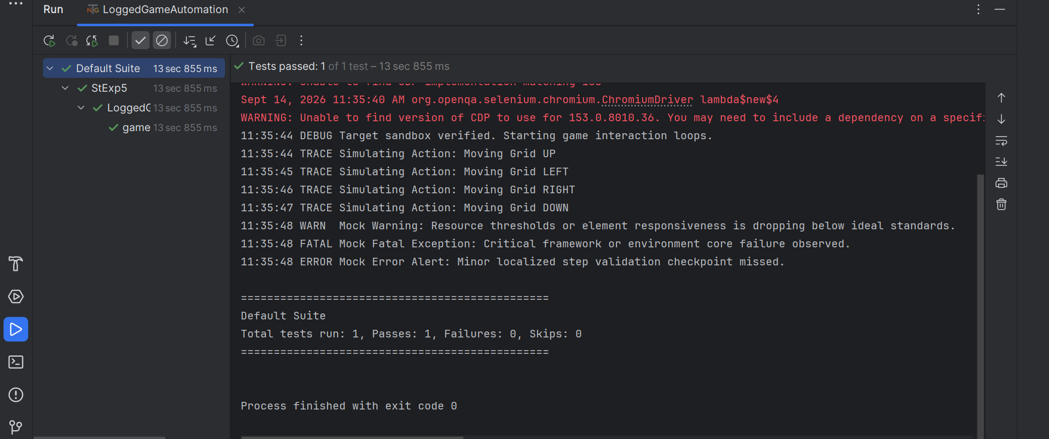
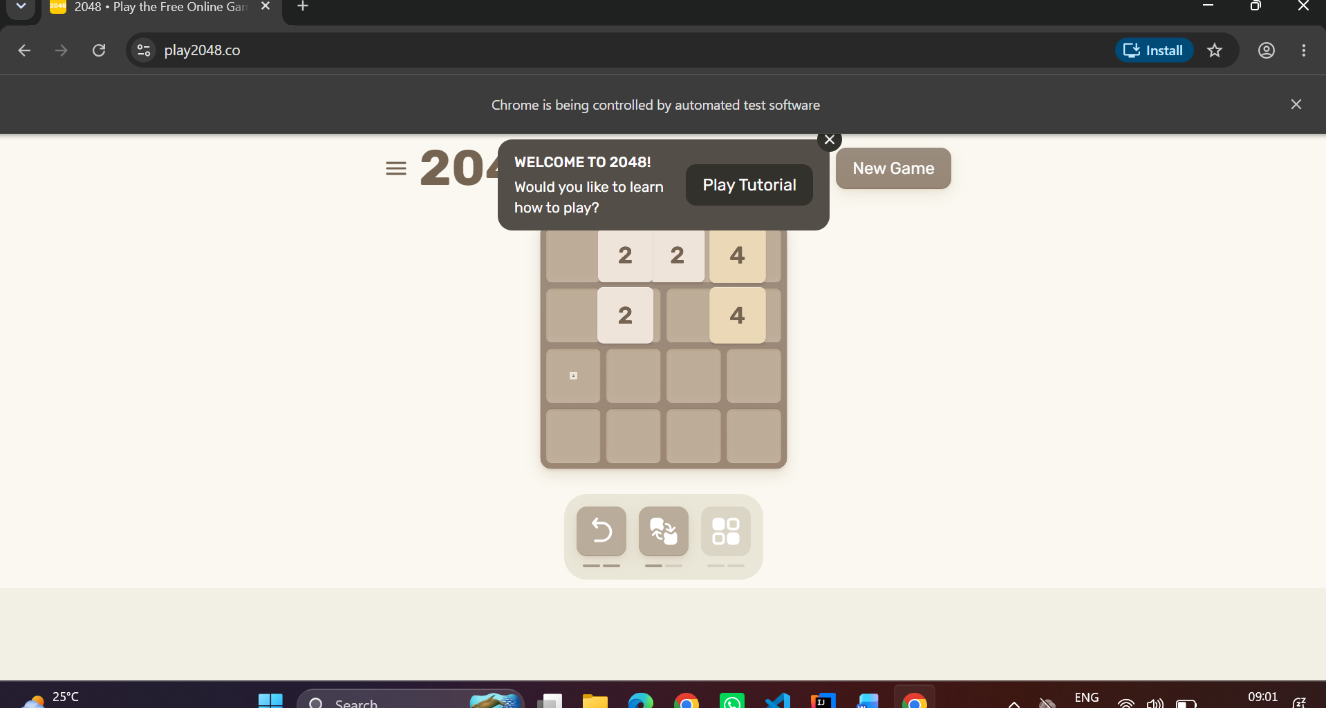

RESULT:
The TestNG-based automation script successfully launched the browser, navigated to
the Google homepage, and verified the title using assertions. All seven logging levels
(TRACE, DEBUG, INFO, WARN, ERROR, FATAL, ALL) were implemented with Log4j,
providing detailed execution tracking for debugging and reporting purposes.
Ex.No:6 | EXECUTE APPLICATION TESTS USING DESIGNED TEST CASES AND GENERATE AN HTML REPORT FOR A COMPREHENSIVE OVERVIEW.

AIM:
To execute automated application tests using pre-designed test cases and generate an
HTML report, providing a comprehensive overview of the execution results including passed,
failed, and skipped test cases.

DESCRIPTION:
In Software Test Automation, HTML reports offer a clear, visual summary of test
execution results for stakeholders and ǪA teams. Using Java, Selenium WebDriver, and
TestNG, we can:
• Create automated test cases for a target web application.
• Execute them in a structured suite.
• Automatically generate an HTML report using TestNG’s built-in reporting mechanism.
This approach improves transparency, provides quick defect identification, and enables better
decision-making based on test metrics.

CODE:
<dependencies>
<dependency>
<groupId>org.testng</groupId>
<artifactId>testng</artifactId>
<version>7.11.0</version>
</dependency>
<dependency>
<groupId>org.seleniumhq.selenium</groupId>
<artifactId>selenium-java</artifactId>
<version>4.33.0</version>
</dependency>
<dependency>
<groupId>com.aventstack</groupId>
<artifactId>extentreports</artifactId>
<version>4.1.7</version>
</dependency>
<dependency>
<groupId>commons-io</groupId>
<artifactId>commons-io</artifactId>
<version>2.16.1</version>
</dependency>
</dependencies>
import org.openqa.selenium.*;
import org.openqa.selenium.chrome.ChromeDriver;
import com.aventstack.extentreports.*;
import com.aventstack.extentreports.reporter.ExtentSparkReporter;
import java.io.File;
import java.nio.file.Files;
import java.nio.file.StandardCopyOption;
public class NewExp_06 {
public static void main(String []args) throws Exception{
new File("6thExp").mkdir();
ExtentReports extentReports = new ExtentReports();
extentReports.attachReporter(new ExtentSparkReporter("6thExp/multipleScreenshots.html"));
ExtentTest test = extentReports.createTest("multipleScreen");
WebDriver driver = new ChromeDriver();
driver.get("https://opensource-demo.orangehrmlive.com/web/index.php/auth/login");
driver.manage().window().maximize();
test.pass("success");
Thread.sleep(4000);
capture(driver,test,"01login");
driver.findElement(By.name("username")).sendKeys("Admin");
driver.findElement(By.name("password")).sendKeys("admin123");
driver.findElement(By.cssSelector("button[type='submit']")).click();
test.pass("test2 passed");
Thread.sleep(3000);
capture(driver,test,"02dashboard");
driver.findElement(By.xpath("//span[text()='Admin']")).click();
test.pass("opened admin");
Thread.sleep(2000);
capture(driver,test,"03Admin");
driver.findElement(By.xpath("//span[text()='PIM']")).click();
test.pass("opened PIM");
Thread.sleep(2000);
capture(driver,test,"04PIM");
driver.findElement(By.cssSelector("p.oxd-userdropdown-name")).click();
driver.findElement(By.linkText("Logout")).click();
test.pass("Logout success");
Thread.sleep(2000);
capture(driver,test,"05Logout");
driver.quit();
extentReports.flush();
}
public static void capture(WebDriver driver, ExtentTest test, String name) throws Exception {
File src = ((TakesScreenshot) driver).getScreenshotAs(OutputType.FILE);
File dest= new File("6thExp/" +name +".png");
Files.copy(src.toPath(),dest.toPath(),StandardCopyOption.REPLACE_EXISTING);
test.addScreenCaptureFromPath(name+".png");
}
}

OUTPUT:

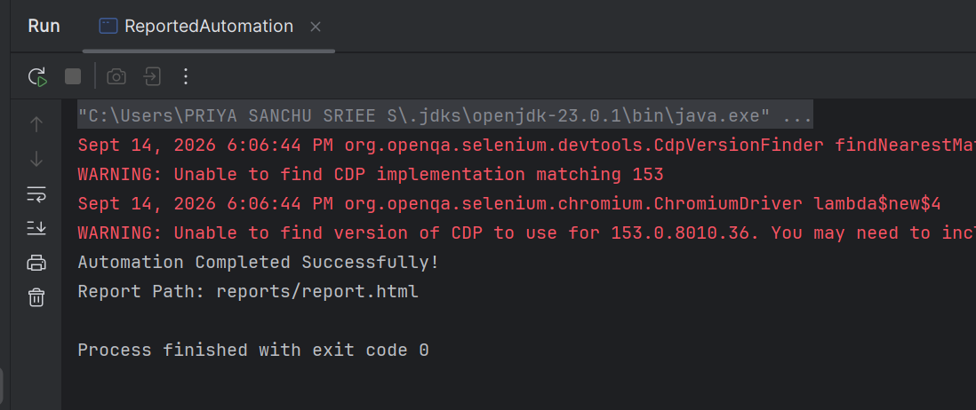
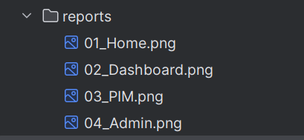

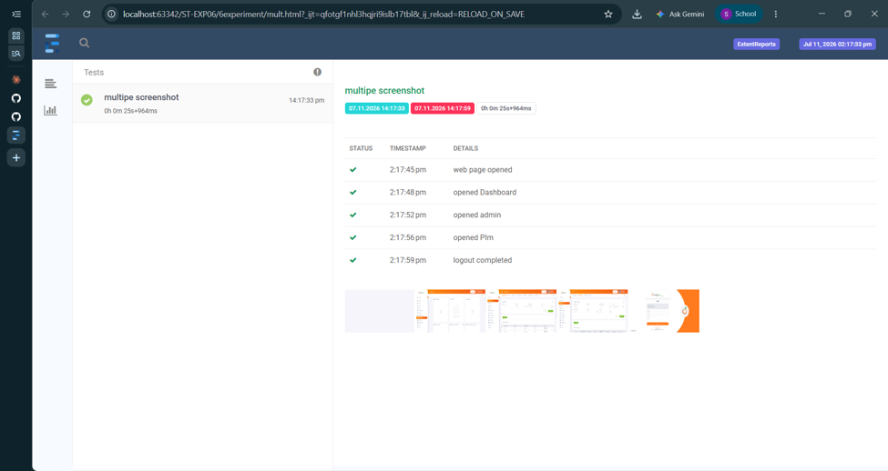

RESULT:
The automated test execution successfully validated both valid and invalid login
scenarios for the application.
Ex.No:7 | DESIGN AND IMPLEMENT A HYBRID FRAMEWORK FOR A TICKET BOOKING SYSTEM, ALONG WITH ASSOCIATED TEST CASES

AIM:
To Design and implement a Hybrid Test Automation Framework for a ticket booking
web app that:
1. separates UI locators into Page Objects (POM),
2. drives flows with keywords,
3. injects scenarios via data files (CSV), and
4. runs via TestNG (Java) with clean reporting.

DESCRIPTION :
• POM layer: Encapsulates page locators C actions (Home, Results, Checkout, Confirmation).
• Keyword layer: Re-usable business steps like LAUNCH_APP, SEARCH_TRIP,
SELECT_FIRST_RESULT, CHECKOUT, ASSERT_STATUS.
• Data layer: CSV/Excel holds routes, dates, passenger info and
keyword sequences.
• Runner layer: TestNG test reads CSV → executes keywords against Page Objects →
assertions.

CODE:
config.properties
browser=chrome
url=https://mouneshgouda.github.io/busBooking/
from=Bangalore
to=Coimbatore
date=08/10/2026
bus=Green Line Travels
name=Mounesh
age=20
phone=9876543210
seat=A1

utils/ConfigReader.java
package utils;
import java.io.FileInputStream;
import java.util.Properties;
public class ConfigReader {
static Properties p = new Properties();
static {
try {
p.load(new FileInputStream(
"src/test/resources/config.properties"));
}
catch (Exception e) {
e.printStackTrace();
}
}
public static String get(String key) {
return p.getProperty(key);
}
}

base/BaseTest.java
package base;
import org.openqa.selenium.WebDriver;
import org.openqa.selenium.chrome.ChromeDriver;
import utils.ConfigReader;
public class BaseTest {
public static WebDriver driver;
public void setup() throws Exception {
driver = new ChromeDriver();
driver.manage().window().maximize();
Thread.sleep(2000);
driver.get(ConfigReader.get("url"));
Thread.sleep(3000);
}
public void close() {
driver.quit();
}
}

pages/HomePage.java
package pages;
import org.openqa.selenium.By;
import org.openqa.selenium.WebDriver;
import org.openqa.selenium.support.ui.Select;
public class HomePage {
WebDriver driver;
public HomePage(WebDriver driver) {
this.driver = driver;
}
public void searchBus(String from, String to, String date) {
Select fromSelect =
new Select(driver.findElement(By.id("from")));
fromSelect.selectByVisibleText(from);
Select toSelect =
new Select(driver.findElement(By.id("to")));
toSelect.selectByVisibleText(to);
driver.findElement(By.id("date")).sendKeys(17-09-2026);
driver.findElement(
By.xpath("//button[contains(text(),'Search Bus')]")
).click();
}
}

pages/BusPage.java
package pages;
import org.openqa.selenium.By;
import org.openqa.selenium.WebDriver;
public class BusPage {
WebDriver driver;
public BusPage(WebDriver driver) {
this.driver = driver;
}
public void selectBus(String busName) {
driver.findElement(
By.xpath("//tr[td='" + busName + "']//button")
).click();
}
}

pages/PassengerPage.java
package pages;
import org.openqa.selenium.By;
import org.openqa.selenium.WebDriver;
public class PassengerPage {
WebDriver driver;
public PassengerPage(WebDriver driver) {
this.driver = driver;
}
public void enterDetails(
String name,
String age,
String phone,
String seat) {
driver.findElement(By.id("name")).sendKeys(name);
driver.findElement(By.id("age")).sendKeys(age);
driver.findElement(By.id("phone")).sendKeys(phone);
driver.findElement(By.id("seat")).sendKeys(seat);
}
public void confirmBooking() {
driver.findElement(
By.xpath("//button[contains(text(),'Book')]")
).click();
}
}

pages/ConfirmationPage.java
package pages;
import org.openqa.selenium.By;
import org.openqa.selenium.WebDriver;
public class ConfirmationPage {
WebDriver driver;
public ConfirmationPage(WebDriver driver) {
this.driver = driver;
}
public boolean verifyBooking() {
return driver.findElement(
By.xpath("//h1[contains(text(),'Booking Confirmed')]")
).isDisplayed();
}
}

tests/BookingTest.java
package tests;
import org.testng.Assert;
import org.testng.annotations.*;
import base.BaseTest;
import pages.*;
import utils.ConfigReader;
public class BookingTest extends BaseTest {
@BeforeMethod
public void start() throws Exception {
setup();
}
@Test
public void bookingTest() {
// Step 1: Search Bus
HomePage home = new HomePage(driver);
home.searchBus(
ConfigReader.get("from"),
ConfigReader.get("to"),
ConfigReader.get("date")
);
// Step 2: Select Bus
BusPage bus = new BusPage(driver);
bus.selectBus(
ConfigReader.get("bus")
);
// Step 3: Enter Passenger Details
PassengerPage passenger = new PassengerPage(driver);
passenger.enterDetails(
ConfigReader.get("name"),
ConfigReader.get("age"),
ConfigReader.get("phone"),
ConfigReader.get("seat")
);
// Step 4: Click Book/Confirm Button
passenger.confirmBooking();
}
@AfterMethod
public void end() {
close();
}
}

OUTPUT:
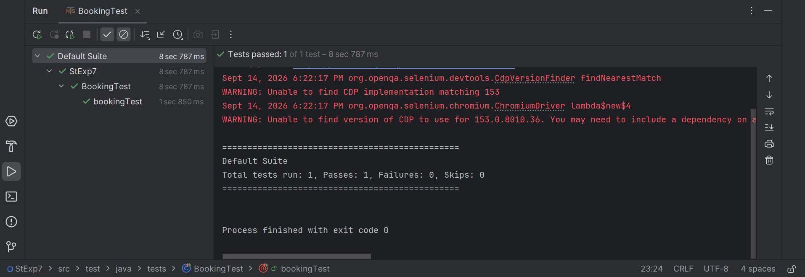

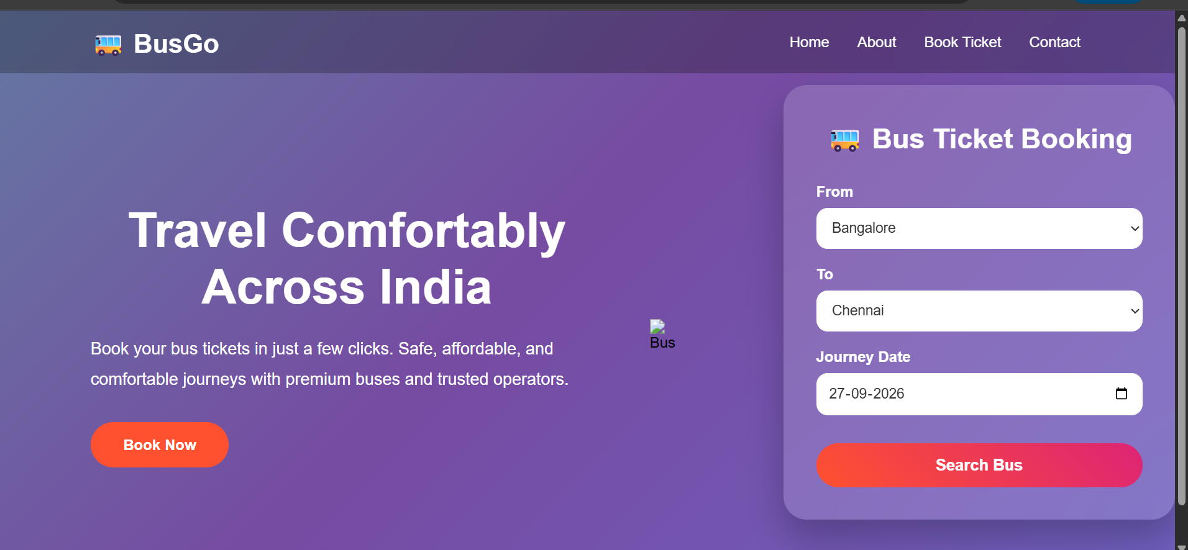

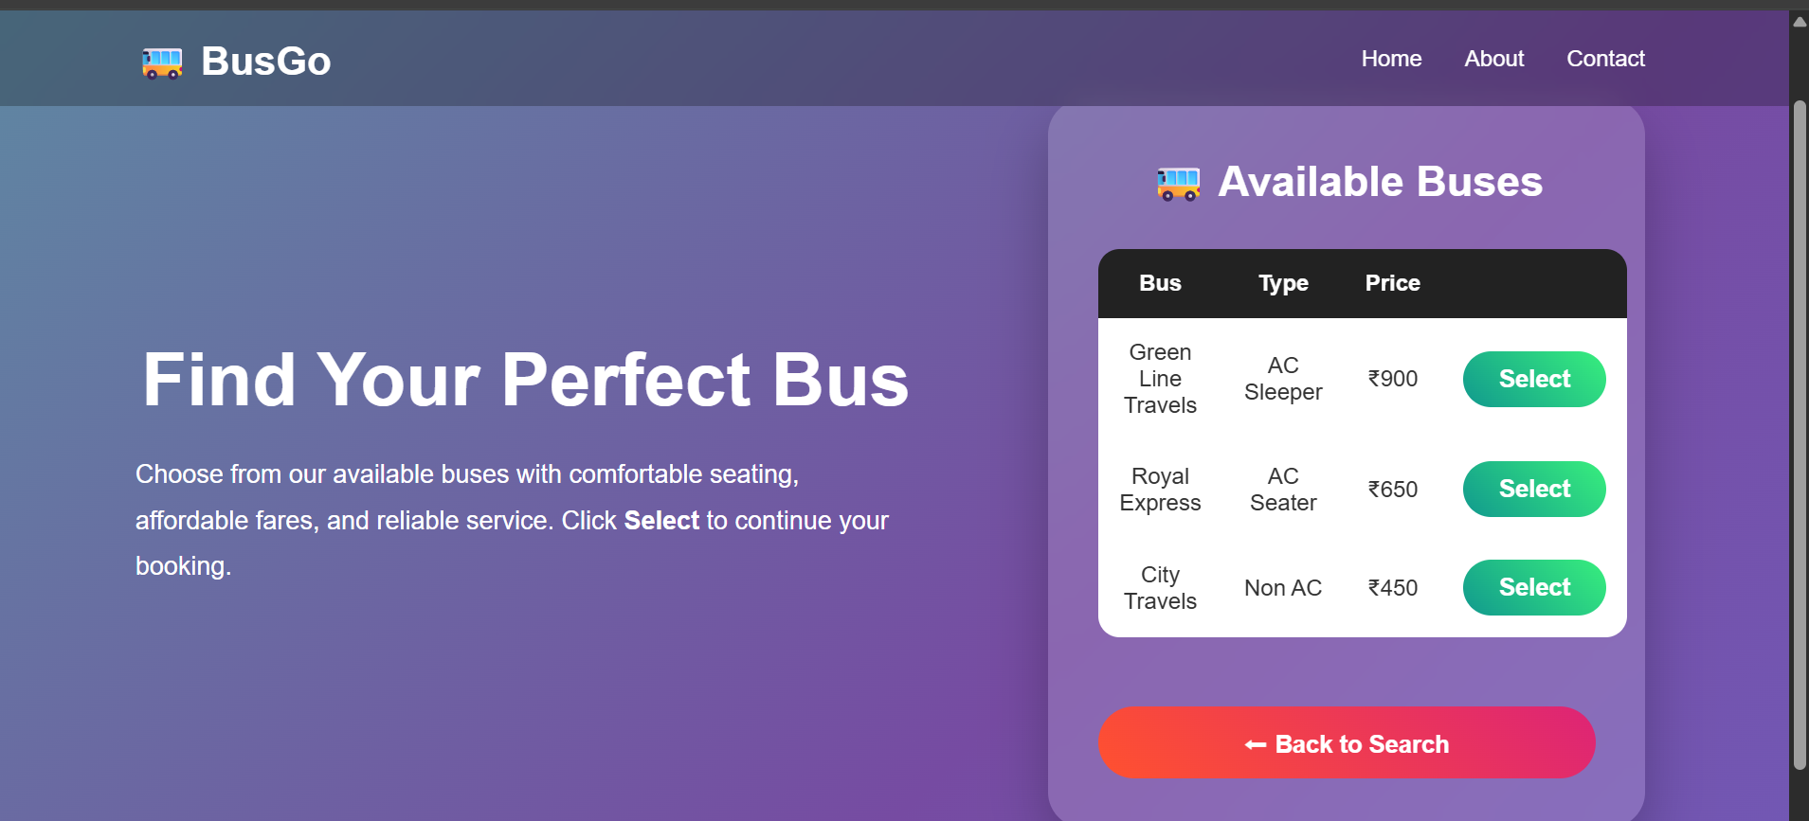

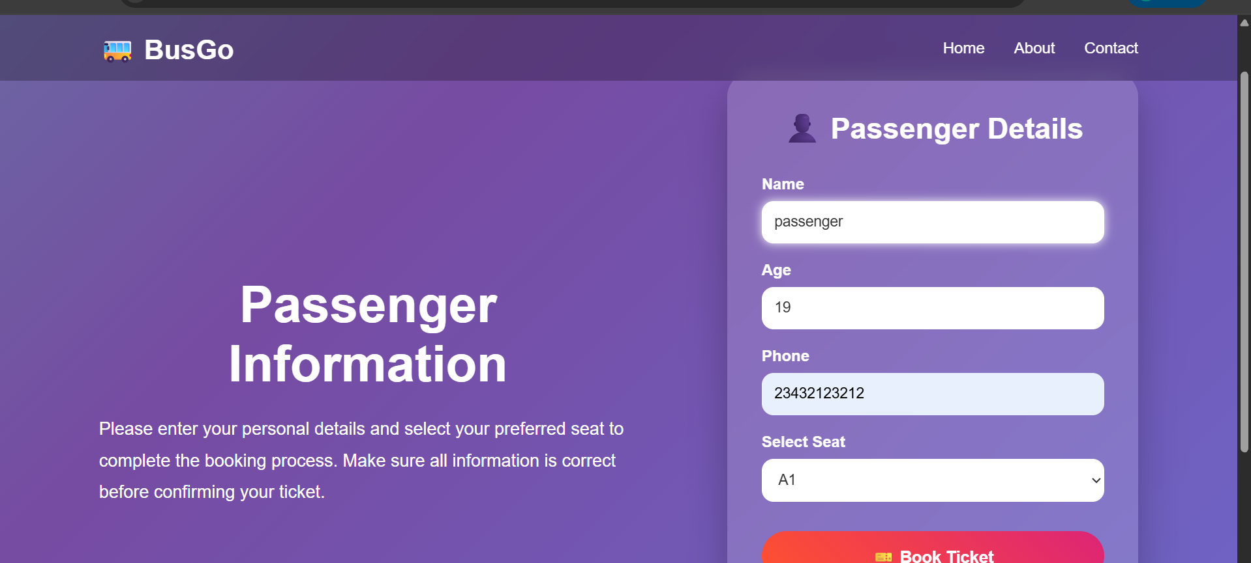

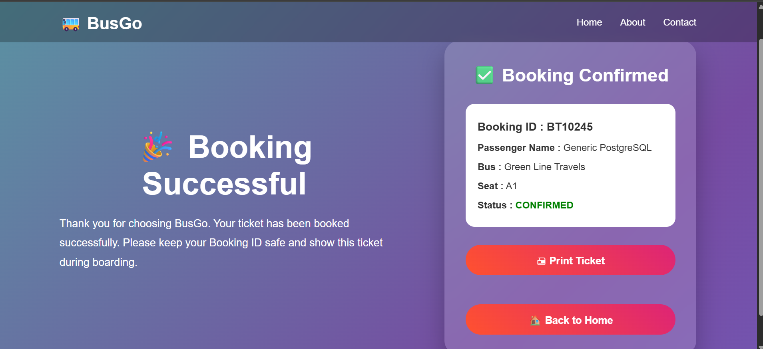

RESULT:
The Hybrid Framework successfully automated the ticket booking workflow using Page
Objects (encapsulated locators/actions), Keywords (business-level steps), and Data-Driven
CSV inputs.
Ex.No:8 | DEVELOP A HYBRID FRAMEWORK AND ASSOCIATED TEST CASES FOR A HOTEL ROOM BOOKING SYSTEM.

AIM:
To design and implement a Hybrid Automation Framework for a hotel room booking
system using Java, Selenium WebDriver, TestNG, and Excel for test data. The framework
should support reusable components, maintainability, and scalability, along with detailed test
reporting.

DESCRIPTION:
The Hybrid Framework is a combination of Data Driven (reading input data from Excel)
and Keyword Driven (using action keywords for reusable methods) approaches, structured
with the Page Object Model (POM).
This framework automates the process of:
1. Navigating to the hotel booking application.
2. Logging in with provided credentials.
3. Searching for a hotel room.
4. Booking the room.
5. Validating the booking confirmation.

CODE:
pages/HomePage.java
package pages;
import org.openqa.selenium.By;
import org.openqa.selenium.WebDriver;
public class HomePage {
WebDriver driver;
public HomePage(WebDriver driver) {
this.driver = driver;
}
public void openWebsite() {
driver.get(
"https://mouneshgouda.github.io/HotelBooking/"
);
}
public void searchRoom(String checkIn, String checkOut, String guests) {
driver.findElement(By.id("checkIn"))
.sendKeys(checkIn);
driver.findElement(By.id("checkOut"))
.sendKeys(checkOut);
driver.findElement(By.id("guests"))
.sendKeys(guests);
driver.findElement(By.id("searchRooms"))
.click();
}
}

pages/RoomsPage.java
package pages;
import org.openqa.selenium.By;
import org.openqa.selenium.WebDriver;
import org.openqa.selenium.WebElement;
import org.openqa.selenium.JavascriptExecutor;
public class RoomsPage {
WebDriver driver;
public RoomsPage(WebDriver driver) {
this.driver = driver;
}
public void bookRoom() throws InterruptedException {
WebElement button =
driver.findElement(
By.xpath("(//button[contains(text(),'Book Reservation')])[1]")
);
JavascriptExecutor js =
(JavascriptExecutor) driver;
js.executeScript(
"arguments[0].scrollIntoView(true);",
button
);
Thread.sleep(1000);
button.click();
}
}

pages/BookingPage.java
package pages;
import org.openqa.selenium.By;
import org.openqa.selenium.WebDriver;
import org.openqa.selenium.WebElement;
import org.openqa.selenium.JavascriptExecutor;
public class BookingPage {
WebDriver driver;
public BookingPage(WebDriver driver) {
this.driver = driver;
}
public void enterDetails() throws InterruptedException {
driver.findElement(By.id("name"))
.sendKeys("Pranith");
driver.findElement(By.id("email"))
.sendKeys("Pranith@gmail.com");
JavascriptExecutor js =
(JavascriptExecutor) driver;
WebElement checkIn =
driver.findElement(By.id("bookingCheckIn"));
js.executeScript(
"arguments[0].value='2026-09-10';",
checkIn
);
WebElement checkOut =
driver.findElement(By.id("bookingCheckOut"));
js.executeScript(
"arguments[0].value='2026-09-12';",
checkOut
);
driver.findElement(By.id("bookingGuests"))
.clear();
driver.findElement(By.id("bookingGuests"))
.sendKeys("2");
Thread.sleep(2000);
}
public void confirmBooking() throws InterruptedException {
WebElement button =
driver.findElement(
By.xpath("//button[contains(text(),'Confirm Reservation')]")
);
JavascriptExecutor js =
(JavascriptExecutor) driver;
js.executeScript(
"arguments[0].scrollIntoView(true);",
button
);
Thread.sleep(1000);
button.click();
}
}

pages/History.java
package pages;
import org.openqa.selenium.WebDriver;
public class HistoryPage {
WebDriver driver;
public HistoryPage(WebDriver driver) {
this.driver = driver;
}
public void verifyPage() {
System.out.println("Booking Done");
}
}

tests/HotelTest.java
package tests;
import org.openqa.selenium.WebDriver;
import org.openqa.selenium.chrome.ChromeDriver;
import org.testng.annotations.*;
import pages.*;
import java.time.Duration;
public class HotelTest {
WebDriver driver;
HomePage home;
RoomsPage rooms;
BookingPage booking;
HistoryPage history;
@BeforeMethod
public void setup() {
driver = new ChromeDriver();
driver.manage().window().maximize();
home = new HomePage(driver);
rooms = new RoomsPage(driver);
booking = new BookingPage(driver);
history = new HistoryPage(driver);
}
@Test
public void hotelBookingTest() throws Exception {
home.openWebsite();
home.searchRoom(
"08/10/2026",
"08/12/2026",
"2"
);
Thread.sleep(2000);
rooms.bookRoom();
Thread.sleep(2000);
booking.enterDetails();
booking.confirmBooking();
Thread.sleep(3000);
history.verifyPage();
}
@AfterMethod
public void tearDown() {
driver.quit();
}
}
}

OUTPUT:
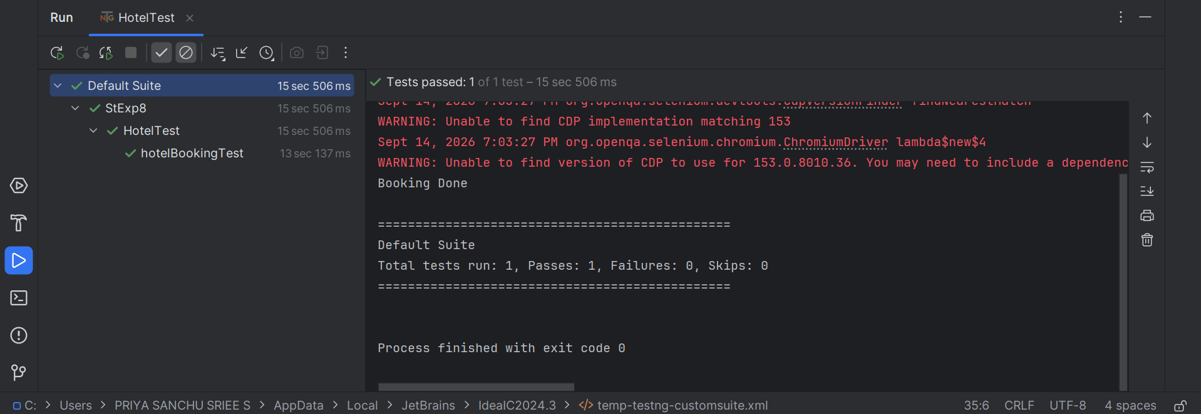

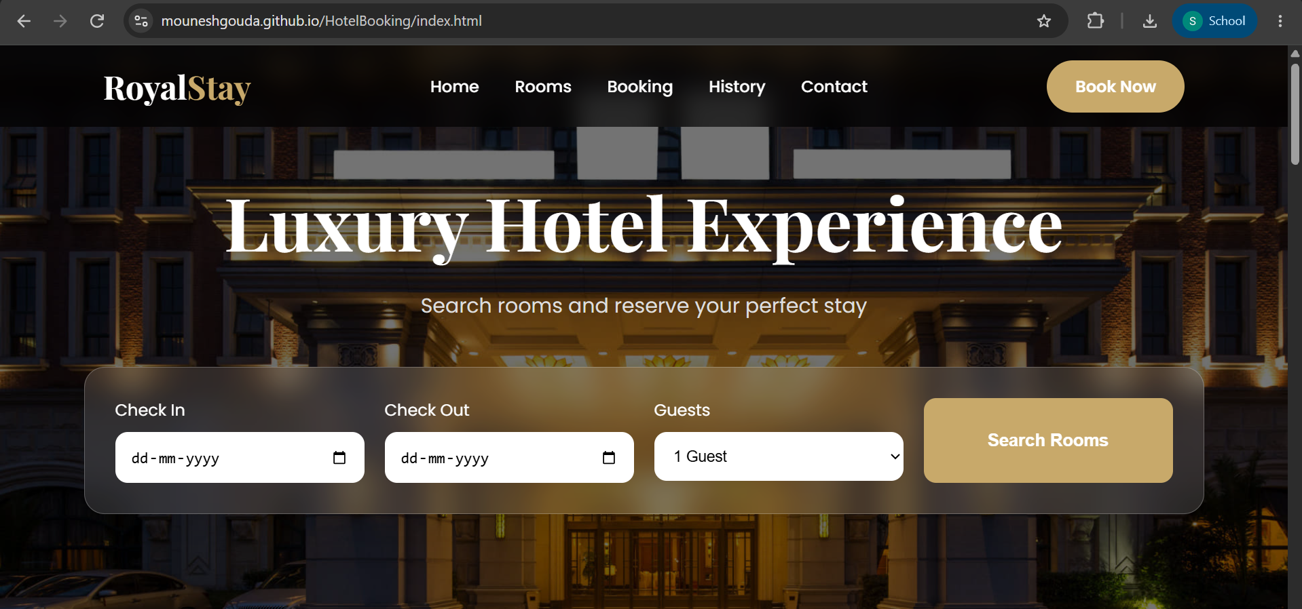
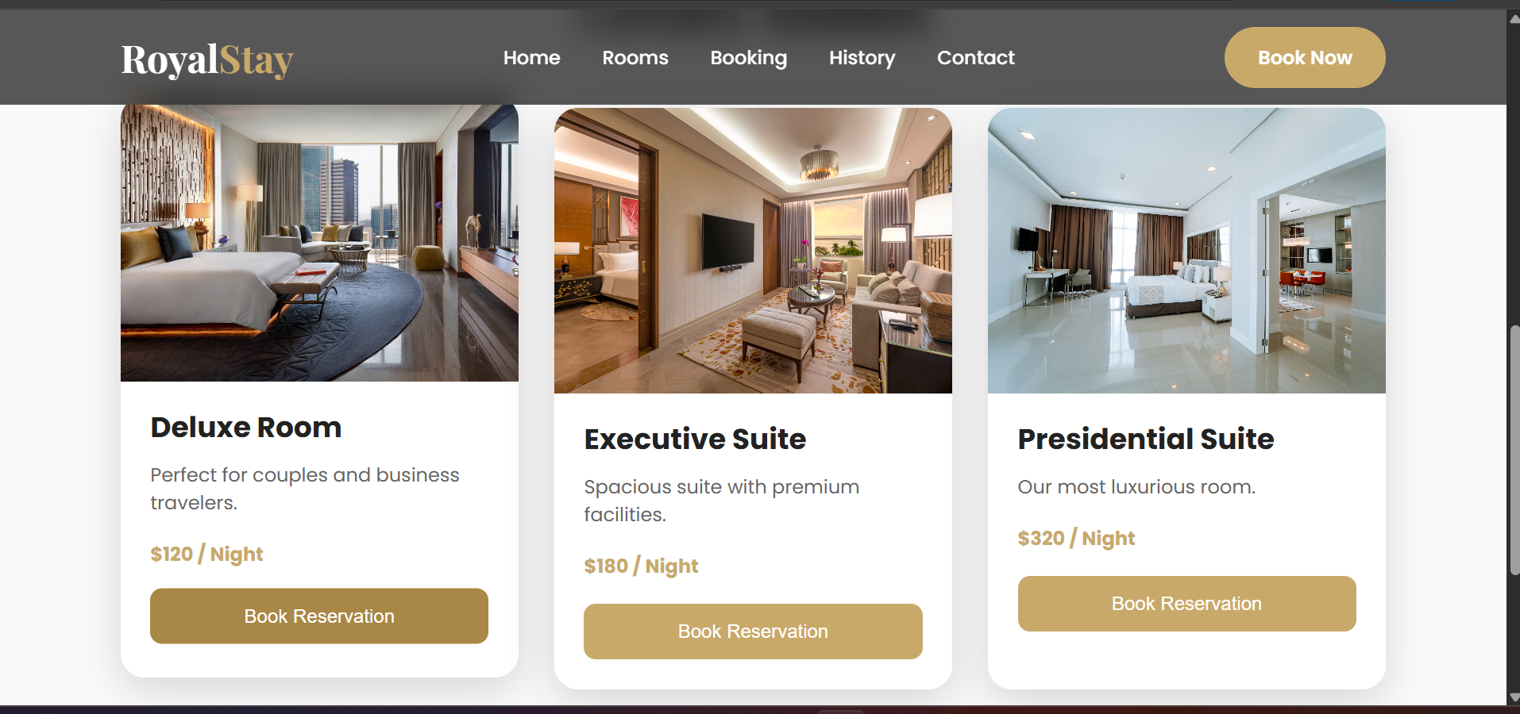

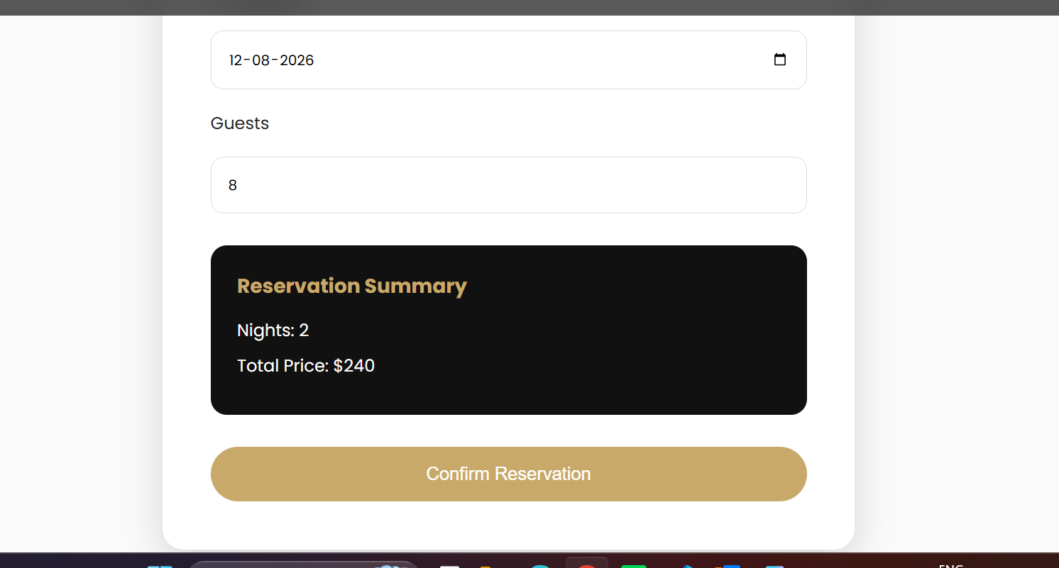

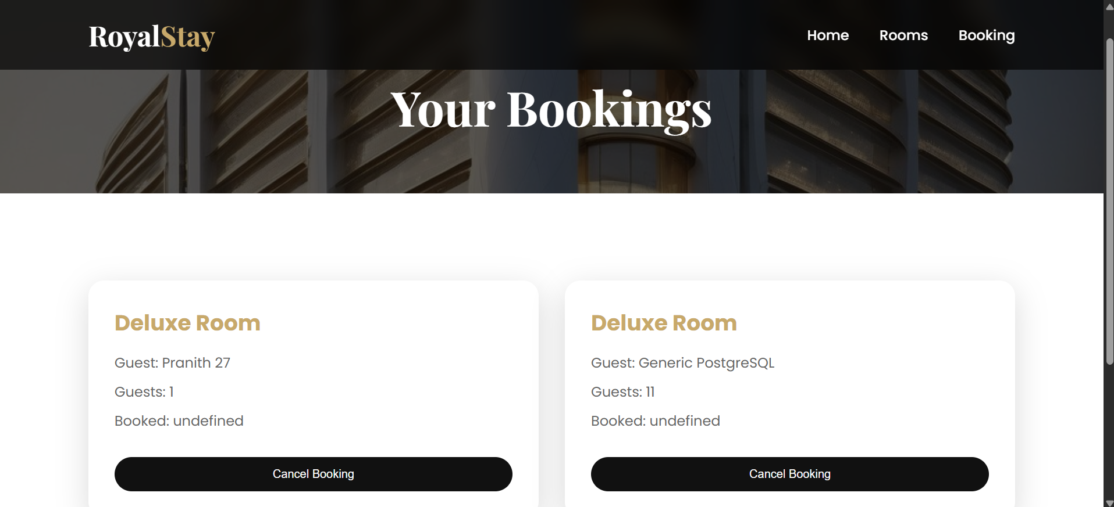

RESULT:
The hybrid framework successfully automated the hotel room booking process using a
combination of Data Driven and Keyword Driven approaches with the Page Object Model.
Ex.No:9 | DESIGN AND DEVELOP A HYBRID FRAMEWORK AND RELEVANT TEST CASES FOR A HOSPITAL APPOINTMENT APPLICATION.

AIM:
To design and implement a Hybrid Automation Framework for a Hospital Appointment
Booking Application using Java, Selenium, and TestNG, enabling efficient automation
through reusable modules, externalized test data, and keyword-driven execution.

DESCRIPTION:
• Hybrid Framework merges the benefits of Data-Driven Framework (test data from
Excel/CSV) and Keyword-Driven Framework (actions defined in keywords).
• The framework will:
o Read test data from Excel.
o Execute actions based on keywords.
o Separate locators, actions, and data for maintainability.
o Provide reusability and easy scalability.
• Modules Included:
o Browser Initialization
o Login
o Appointment Booking
o Logout

CODE:
pages\DepartmentPage.java
package pages;
import org.openqa.selenium.By;
import org.openqa.selenium.WebDriver;
public class DepartmentPage {
WebDriver driver;
public DepartmentPage(WebDriver driver) {
this.driver = driver;
}
public void selectCardiology() {
driver.findElement(
By.cssSelector(".department[data-dept='Cardiology']")
).click();
}
}

pages\DoctorPage.java
package pages;
import org.openqa.selenium.By;
import org.openqa.selenium.WebDriver;
import org.openqa.selenium.WebElement;
public class DoctorPage {
WebDriver driver;
public DoctorPage(WebDriver driver) {
this.driver = driver;
}
public void selectDoctor() {
WebElement doctor = driver.findElement(
By.xpath("//h4[normalize-space()='Dr. Ananya Rao']")
);
doctor.findElement(
By.xpath("./ancestor::div[contains(@class,'doctor')]")
).click();
}
public void clickNext() {
driver.findElement(By.id("doctorNext")).click();
}
}

pages\AppointmentPage.java
package pages;
import org.openqa.selenium.By;
import org.openqa.selenium.JavascriptExecutor;
import org.openqa.selenium.WebDriver;
import org.openqa.selenium.WebElement;
public class AppointmentPage {
WebDriver driver;
public AppointmentPage(WebDriver driver) {
this.driver = driver;
}
public void selectDate() {
WebElement date = driver.findElement(
By.cssSelector(".date")
);
JavascriptExecutor js = (JavascriptExecutor) driver;
js.executeScript(
"arguments[0].scrollIntoView({block:'center'});",
date
);
date.click();
}
public void selectTime() {
driver.findElement(
By.cssSelector(".time:not(.booked)")
).click();
}
public void clickNext() {
driver.findElement(
By.id("dateNext")
).click();
}
}

pages\PatientPage.java
package pages;
import org.openqa.selenium.By;
import org.openqa.selenium.WebDriver;
public class PatientPage {
WebDriver driver;
public PatientPage(WebDriver driver) {
this.driver = driver;
}
public void enterPatientDetails() {
driver.findElement(
By.id("patientName")
).sendKeys("Pranith");
driver.findElement(
By.id("phone")
).sendKeys("9876543210");
driver.findElement(
By.id("email")
).sendKeys("Pranith@gmail.com");
driver.findElement(
By.id("dob")
).sendKeys("06/22/2006");
driver.findElement(
By.id("gender")
).sendKeys("Female");
driver.findElement(
By.id("patientType")
).sendKeys("New patient");
driver.findElement(
By.id("reason")
).sendKeys("Regular consultation");
}
public void clickNext() {
driver.findElement(
By.id("patientNext")
).click();
}
public void confirmAppointment() {
driver.findElement(
By.id("confirmButton")
).click();
}
public String getBookingId() {
return driver.findElement(
By.id("bookingId")
).getText();
}
}

tests\HospitalAppointmentTest.java
package tests;
import org.openqa.selenium.WebDriver;
import org.openqa.selenium.chrome.ChromeDriver;
import org.testng.Assert;
import org.testng.annotations.AfterMethod;
import org.testng.annotations.BeforeMethod;
import org.testng.annotations.Test;
import pages.AppointmentPage;
import pages.DepartmentPage;
import pages.DoctorPage;
import pages.PatientPage;
public class HospitalAppointmentTest {
WebDriver driver;
DepartmentPage departmentPage;
DoctorPage doctorPage;
AppointmentPage appointmentPage;
PatientPage patientPage;
@BeforeMethod
public void setup() {
driver = new ChromeDriver();
driver.get(
"https://mouneshgouda.github.io/Hospital-Appointment/"
);
driver.manage().window().maximize();
departmentPage = new DepartmentPage(driver);
doctorPage = new DoctorPage(driver);
appointmentPage = new AppointmentPage(driver);
patientPage = new PatientPage(driver);
}
@Test
public void bookHospitalAppointment() {
// 1. Select Cardiology
departmentPage.selectCardiology();
// 2. Select Doctor
doctorPage.selectDoctor();
// 3. Continue
doctorPage.clickNext();
// 4. Select Date
appointmentPage.selectDate();
// 5. Select Time
appointmentPage.selectTime();
// 6. Continue
appointmentPage.clickNext();
// 7. Enter Patient Details
patientPage.enterPatientDetails();
// 8. Continue
patientPage.clickNext();
// 9. Confirm Appointment
patientPage.confirmAppointment();
// 10. Get Appointment ID
String appointmentId = patientPage.getBookingId();
System.out.println(
"Appointment booked successfully!"
);
System.out.println(
"Appointment ID: " + appointmentId
);
// TestNG validation
Assert.assertTrue(
appointmentId != null && !appointmentId.isEmpty(),
"Appointment ID was not generated"
);
}
@AfterMethod
public void tearDown() throws InterruptedException {
Thread.sleep(3000);
driver.quit();
}
}

OUTPUT:
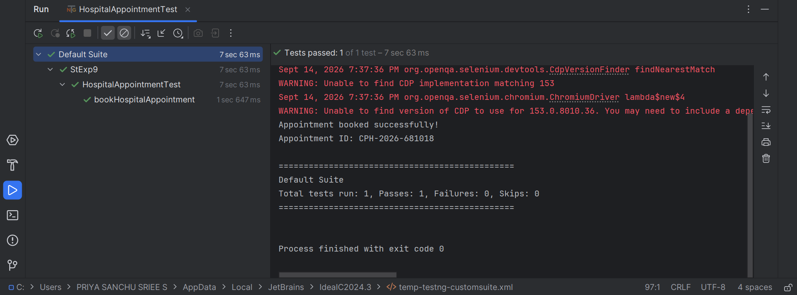

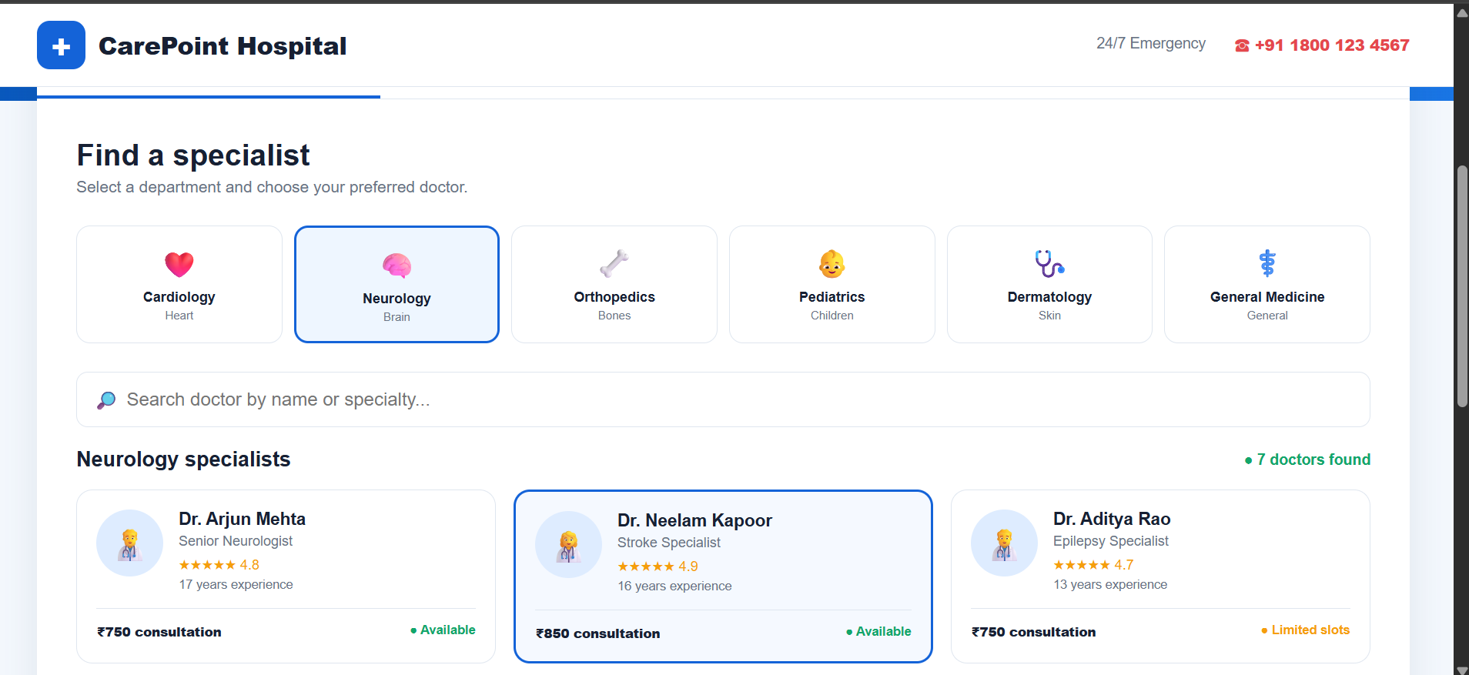

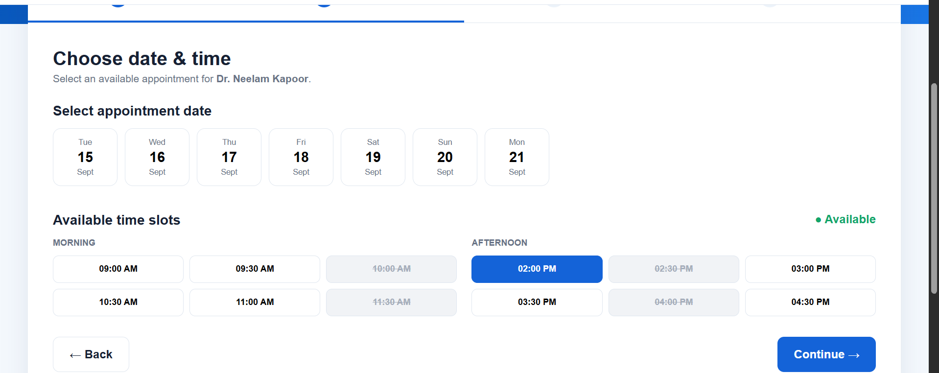

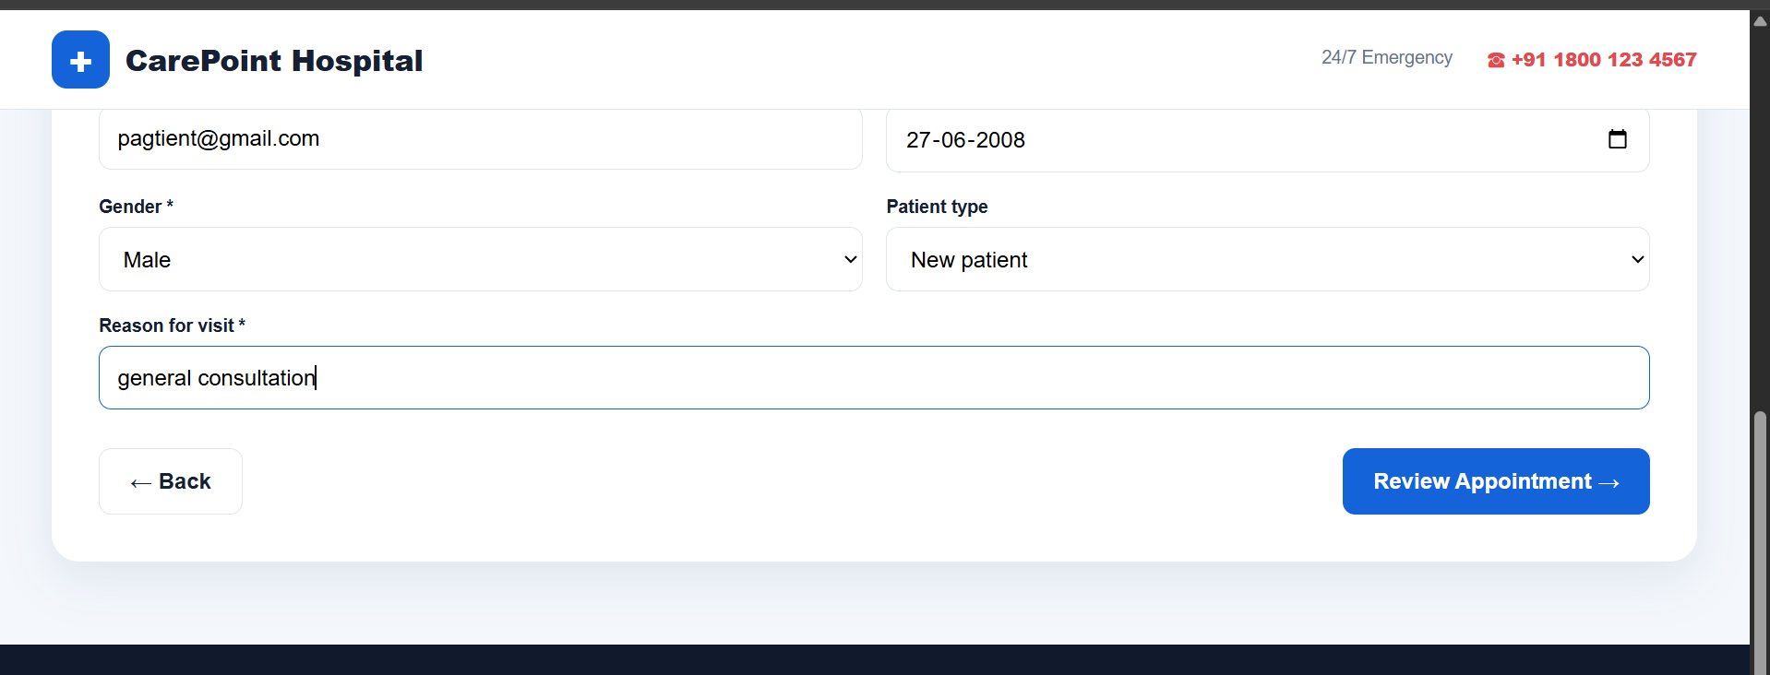

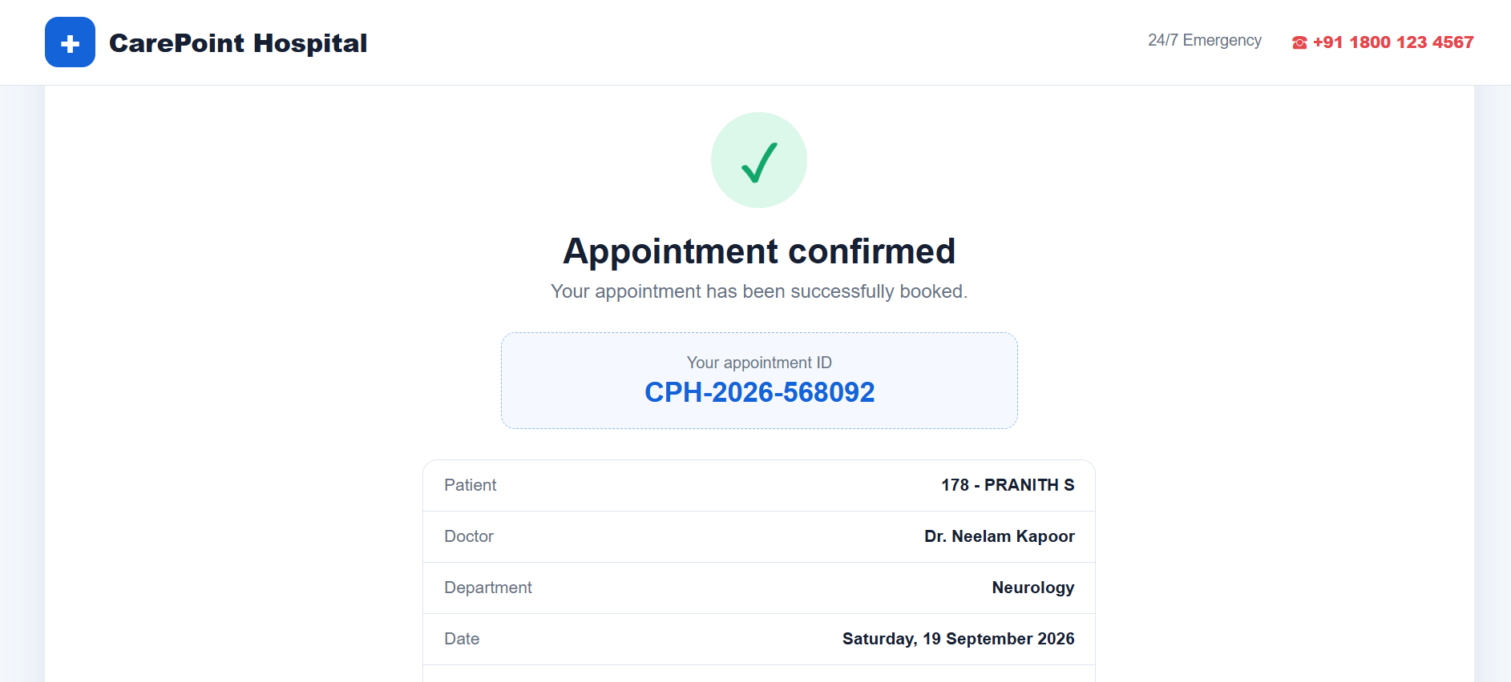

RESULT:
The Hybrid Framework successfully automated the Hospital Appointment Booking
Application, allowing execution of multiple test cases with varying input data from Excel.
Ex.No:10 | IMPLEMENT A HYBRID FRAMEWORK AND ASSOCIATED TEST CASES FOR AN E-COMMERCE APPLICATION.

AIM:
To design and implement a Hybrid Automation Framework for an e-commerce web
application that supports data-driven testing, keyword-driven testing, and reusable page
object components, and to validate core functionalities such as product search, adding to cart,
and checkout through automated test cases.

DESCRIPTION:
A Hybrid Framework combines features of multiple automation frameworks — mainly
Data-Driven, Keyword-Driven, and Page Object Model (POM).
In this implementation:
• Data-Driven: Uses Excel for test data.
• Keyword-Driven: Uses keywords to represent actions in scripts.
• POM: Separates UI locators and methods from test logic.
• TestNG: Provides test structure and HTML reports.
• Apache POI: Reads test data from Excel.
• Log4j: Generates detailed logs.

CODE:
pages/HomePage.java
package pages;
import org.openqa.selenium.By;
import org.openqa.selenium.WebDriver;
public class HomePage {
private WebDriver driver;
private By searchBox = By.id("search_input");
private By firstProduct = By.xpath("//a[contains(text(),'Samsung galaxy s6')]");
public HomePage(WebDriver driver) {
this.driver = driver;
}
public void selectFirstProduct() {
driver.findElement(firstProduct).click();
}
}

pages/ProductPage.java
package pages;
import org.openqa.selenium.By;
import org.openqa.selenium.WebDriver;
public class ProductPage {
private WebDriver driver;
private By addToCartBtn = By.xpath("//a[text()='Add to cart']");
public ProductPage(WebDriver driver) {
this.driver = driver;
}
public void addToCart() {
driver.findElement(addToCartBtn).click();
}
}

base/BaseTest.java
package pages;
import org.openqa.selenium.By;
import org.openqa.selenium.WebDriver;
public class ProductPage {
private WebDriver driver;
private By addToCartBtn = By.xpath("//a[text()='Add to cart']");
public ProductPage(WebDriver driver) {
this.driver = driver;
}
public void addToCart() {
driver.findElement(addToCartBtn).click();
}
}

tests/EcommerceTest.java
package tests;
import base.BaseTest;
import pages.HomePage;
import pages.ProductPage;
import org.openqa.selenium.By;
import org.testng.Assert;
import org.testng.annotations.Test;
public class EcommerceTest extends BaseTest {
@Test
public void testAddProductToCart() throws InterruptedException {
HomePage home = new HomePage(driver);
ProductPage product = new ProductPage(driver);
// Select product
home.selectFirstProduct();
Thread.sleep(2000);
// Add product to cart
product.addToCart();
Thread.sleep(2000);
// Accept alert
driver.switchTo().alert().accept();
// Open cart
driver.findElement(By.id("cartur")).click();
Thread.sleep(2000);
// Verify product is present
String cartText = driver.findElement(By.xpath("//td[contains(text(),'Samsung galaxy s6')]")).getText();
Assert.assertTrue(cartText.contains("Samsung"), "Product not found in cart!");
System.out.println("Product added to cart successfully!");
}
}

OUTPUT:
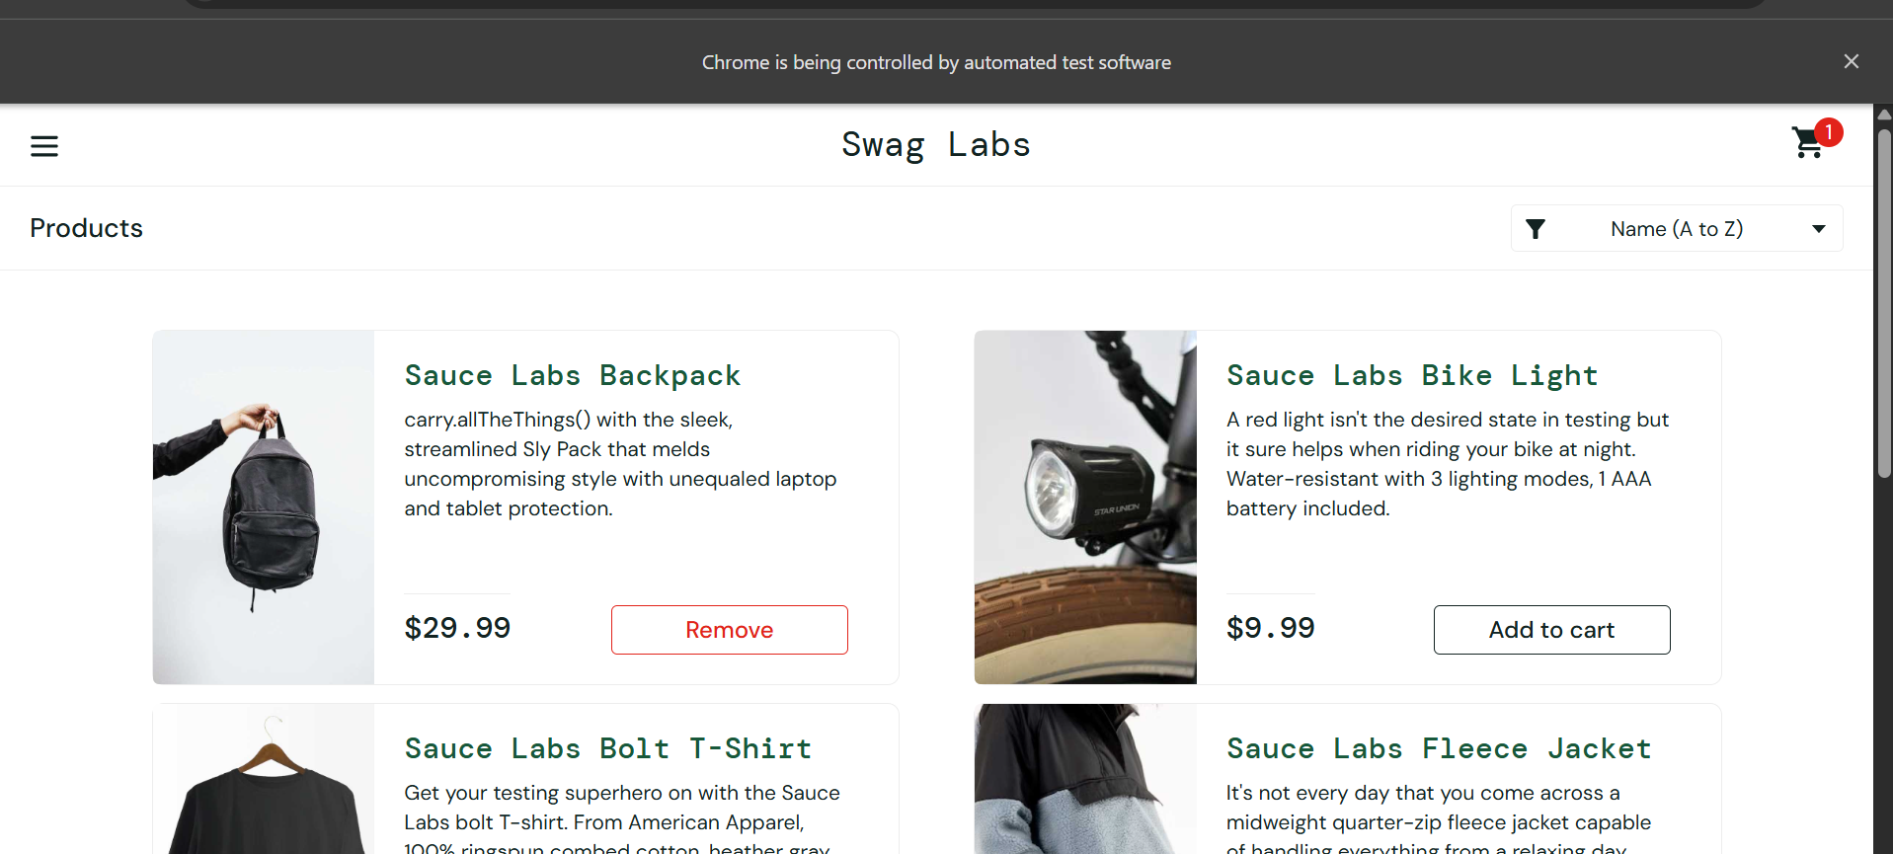

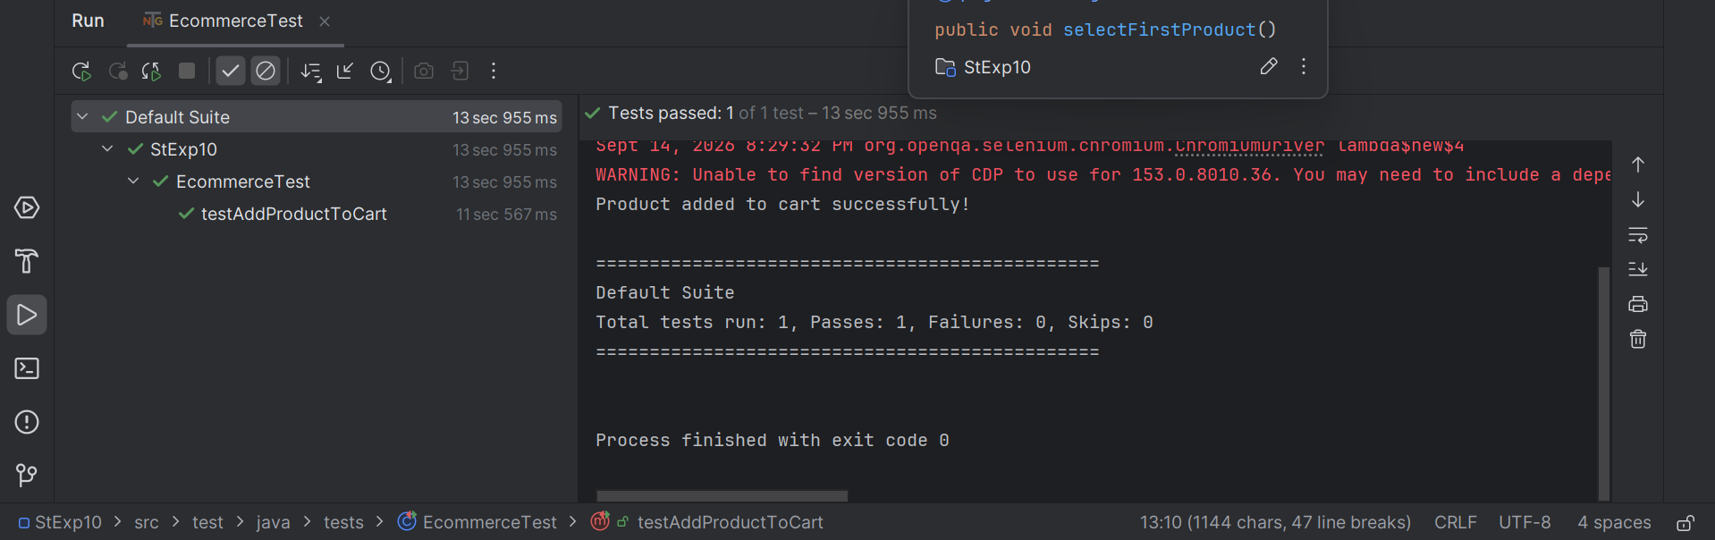

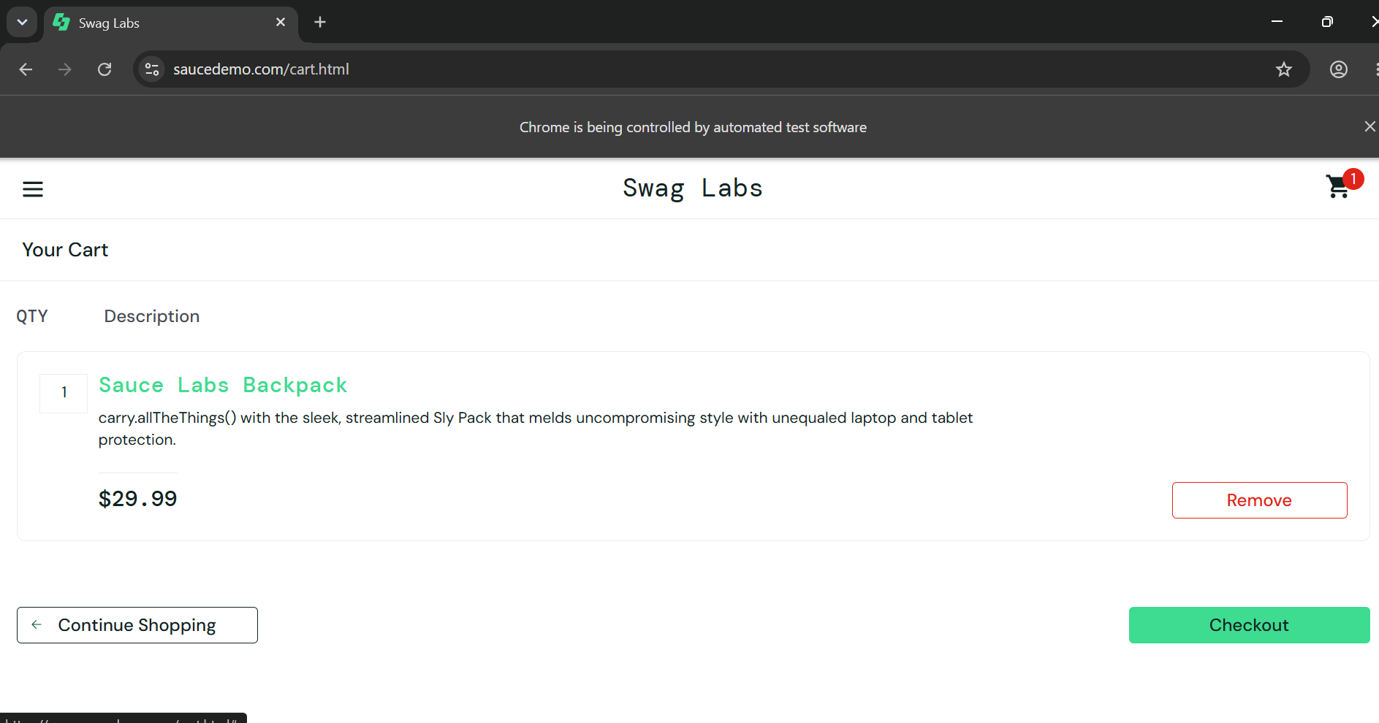

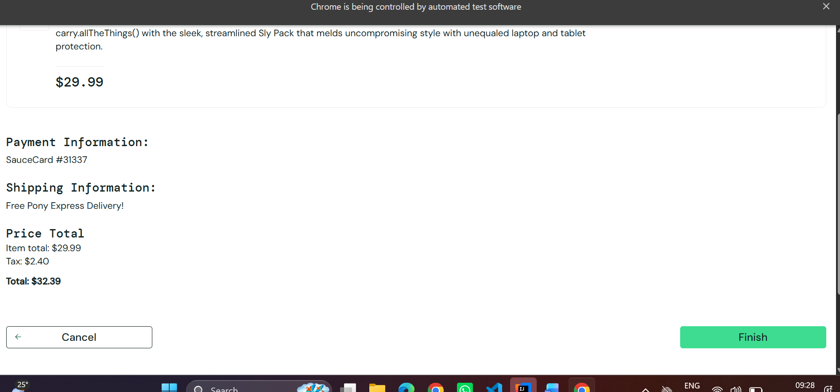

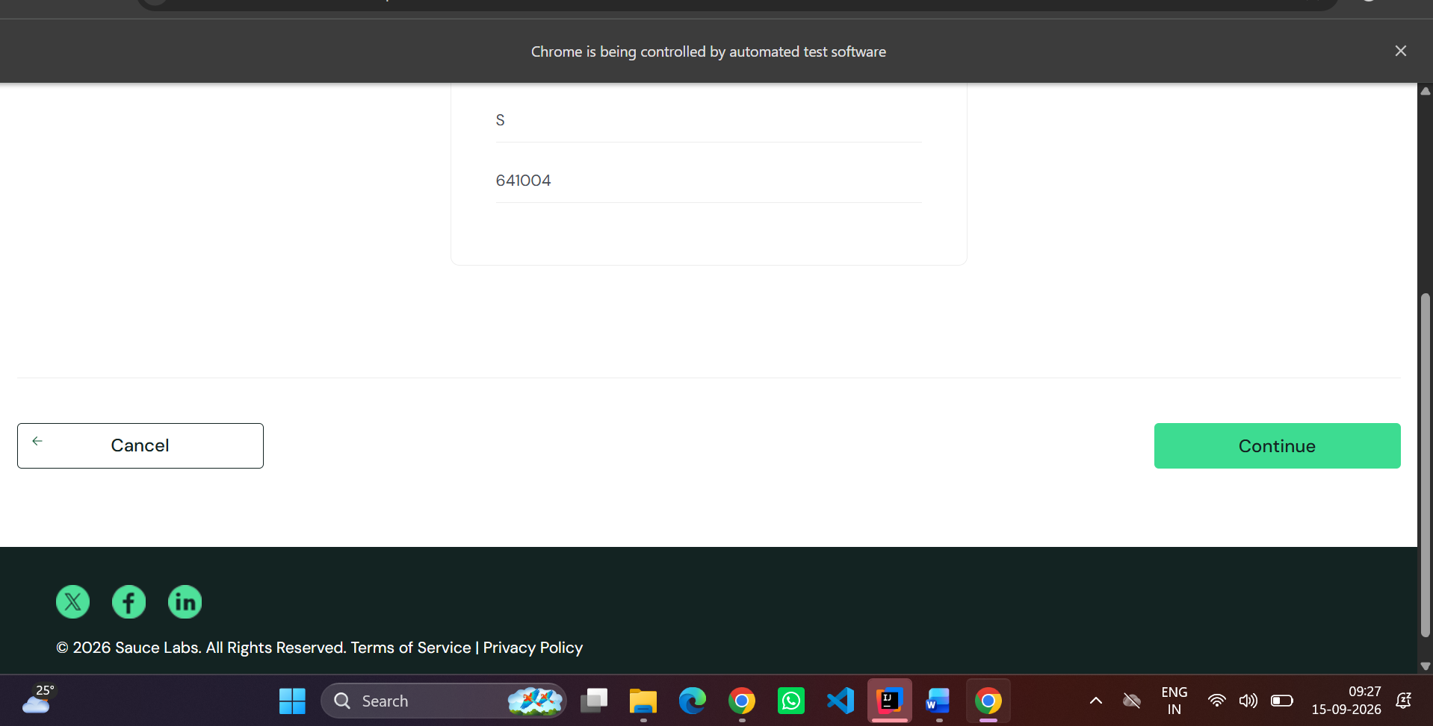
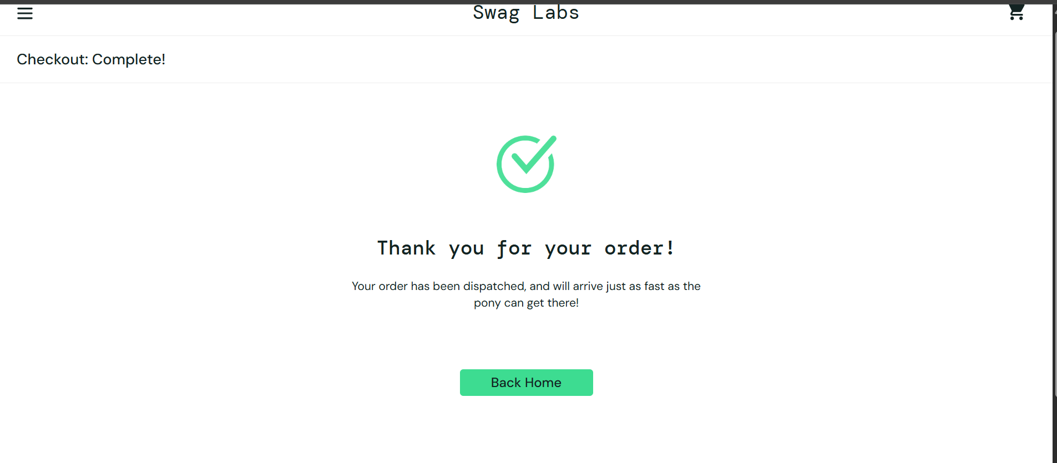

RESULT:
The Hybrid Framework successfully automated the core e-commerce functionality of
adding a product to the cart using a combination of Data-Driven Testing, Keyword-Driven
Actions, and Page Object Model.
Ex.No:11 | DEVELOP A HYBRID FRAMEWORK AND DESIGN TEST CASES FOR COMPREHENSIVE TESTING OF AN INSURANCE WEBSITE

AIM:
To design and implement a Hybrid Test Automation Framework for an Insurance
Website that combines data-driven, keyword-driven, and Page Object Model (POM)
approaches to efficiently automate UI and functional testing.

DESCRIPTION:
The hybrid framework will:
• Use POM for separation of page locators and actions.
• Implement keyword-driven testing to trigger actions based on keywords in an external file.
• Use data-driven testing with Excel to provide dynamic test data.
• Integrate TestNG for test execution, reporting, and assertions.
• Support scalability for multiple insurance modules like Policy Search, Premium
Calculation, and Claim Submission.

CODE:
base\BaseTest.java
package base;
import org.openqa.selenium.WebDriver;
import org.openqa.selenium.chrome.ChromeDriver;
public class BaseTest {
protected WebDriver driver;
public void setup() {
driver = new ChromeDriver();
driver.manage().window().maximize();
driver.get(
"https://mouneshgouda.github.io/Insurence/"
);
}
public void tearDown() {
driver.quit();
}
}

pages\HomePage.java
package pages;
import org.openqa.selenium.By;
import org.openqa.selenium.JavascriptExecutor;
import org.openqa.selenium.WebDriver;
public class HomePage {
WebDriver driver;
public HomePage(WebDriver driver) {
this.driver = driver;
}
public void clickGetQuote() throws InterruptedException {
Thread.sleep(1000);
driver.findElement(By.className("primary-btn")).click();
Thread.sleep(1000);
}
public void scrollDown() throws InterruptedException {
((JavascriptExecutor) driver).executeScript(
"window.scrollTo(0, 500);"
);
Thread.sleep(500);
}
}

pages\InsurancePage.java
package pages;
import org.openqa.selenium.By;
import org.openqa.selenium.WebDriver;
public class InsurancePage {
WebDriver driver;
public InsurancePage(WebDriver driver) {
this.driver = driver;
}
public void selectCar() throws InterruptedException {
driver.findElement(
By.cssSelector(".insurance[data-type='Car']")
).click();
Thread.sleep(500);
}
public void clickNext() throws InterruptedException {
driver.findElement(By.id("nextBtn")).click();
Thread.sleep(1000);
}
}
pages\PlanPage.java
package pages;
import org.openqa.selenium.By;
import org.openqa.selenium.WebDriver;
public class PlanPage {
WebDriver driver;
public PlanPage(WebDriver driver) {
this.driver = driver;
}
public void selectStandard() throws InterruptedException {
driver.findElement(
By.cssSelector(".plan[data-plan='Standard']")
).click();
Thread.sleep(500);
}
public void clickNext() throws InterruptedException {
driver.findElement(By.id("nextBtn")).click();
Thread.sleep(1000);
}
}
pages\DetailsPage.java
package pages;
import org.openqa.selenium.By;
import org.openqa.selenium.WebDriver;
public class DetailsPage {
WebDriver driver;
public DetailsPage(WebDriver driver) {
this.driver = driver;
}
public void enterDetails() throws InterruptedException {
driver.findElement(By.id("firstName")).sendKeys("John");
driver.findElement(By.id("lastName")).sendKeys("Smith");
driver.findElement(By.id("email")).sendKeys("john@gmail.com");
driver.findElement(By.id("age")).sendKeys("30");
Thread.sleep(500);
}
public void clickNext() throws InterruptedException {
driver.findElement(By.id("nextBtn")).click();
Thread.sleep(1000);
}
}
pages\ConfirmationPage.java
package pages;
import org.openqa.selenium.By;
import org.openqa.selenium.WebDriver;
public class ConfirmationPage {
WebDriver driver;
public ConfirmationPage(WebDriver driver) {
this.driver = driver;
}
public void clickConfirm() throws InterruptedException {
driver.findElement(By.id("nextBtn")).click();
Thread.sleep(1000);
}
public String getSuccessMessage() {
return driver.findElement(By.cssSelector(".success h2")).getText();
}
}

tests\InsuranceTest.java
package tests;
import base.BaseTest;
import pages.ConfirmationPage;
import pages.DetailsPage;
import pages.HomePage;
import pages.InsurancePage;
import pages.PlanPage;
import org.testng.Assert;
import org.testng.annotations.AfterMethod;
import org.testng.annotations.BeforeMethod;
import org.testng.annotations.Test;
public class InsuranceTest extends BaseTest {
// Before Test
@BeforeMethod
public void beforeTest() {
setup();
}
// Test Case
@Test
public void getCarInsuranceQuote() throws InterruptedException {
// Create Page Objects
HomePage homePage = new HomePage(driver);
InsurancePage insurancePage = new InsurancePage(driver);
PlanPage planPage = new PlanPage(driver);
DetailsPage detailsPage = new DetailsPage(driver);
ConfirmationPage confirmationPage =
new ConfirmationPage(driver);
// Step 1: Get Quote
homePage.clickGetQuote();
homePage.scrollDown();
// Step 2: Select Car Insurance
insurancePage.selectCar();
insurancePage.clickNext();
// Step 3: Select Standard Plan
planPage.selectStandard();
planPage.clickNext();
// Step 4: Enter Details
detailsPage.enterDetails();
detailsPage.clickNext();
// Step 5: Confirm
confirmationPage.clickConfirm();
// Step 6: Verify Success Message
String message =
confirmationPage.getSuccessMessage();
System.out.println("Message: " + message);
}
@AfterMethod
public void afterTest() {
teardown();
System.out.println("Browser closed");}}
OUTPUT:
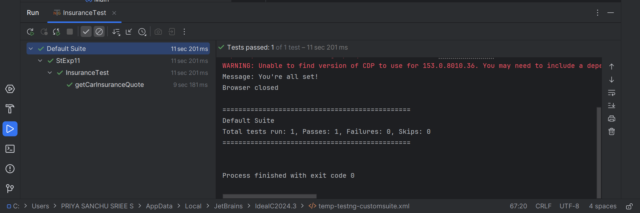
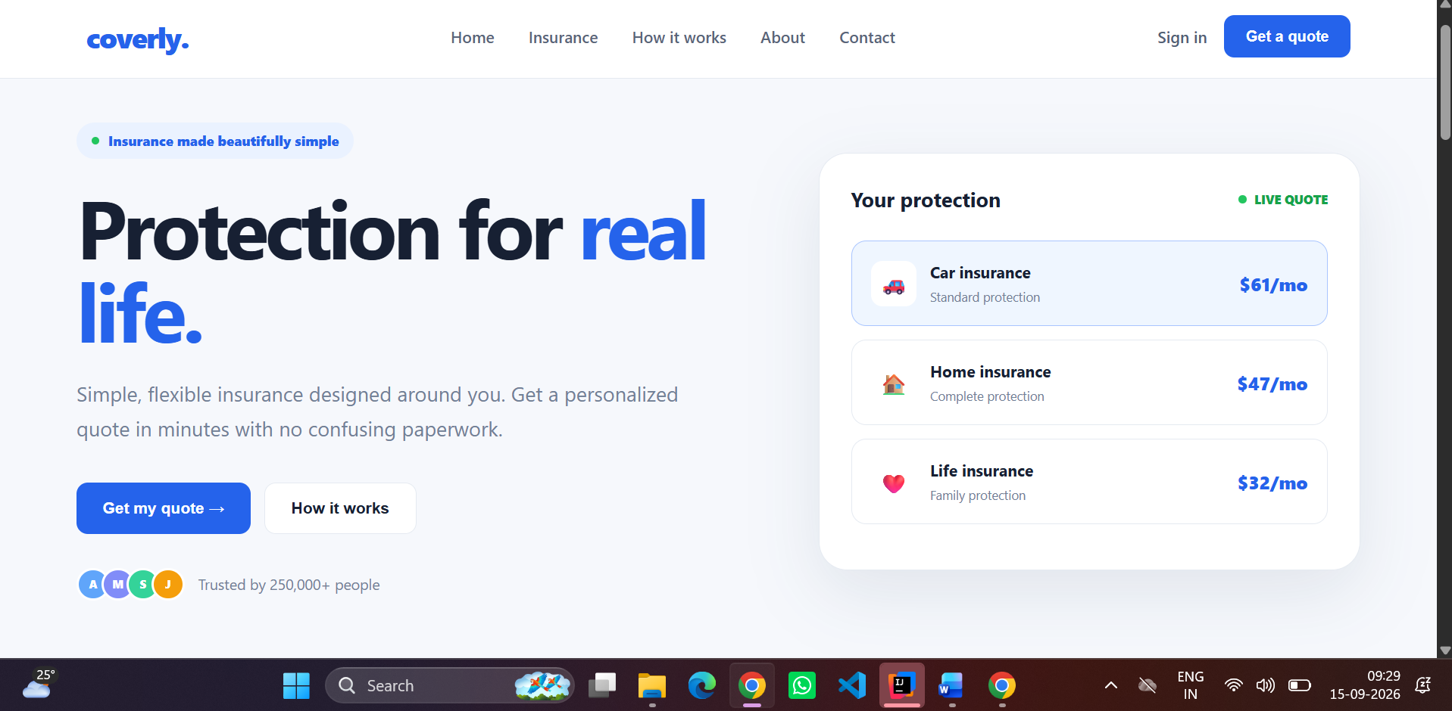

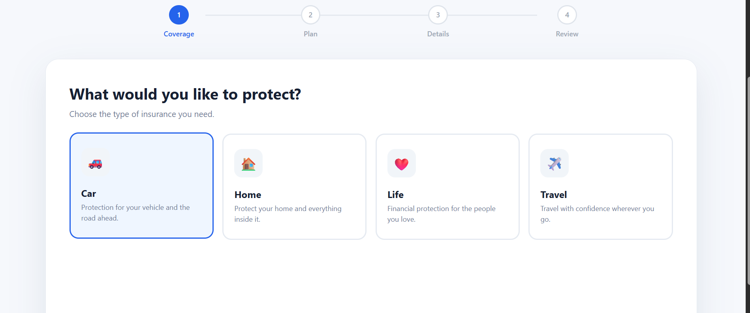

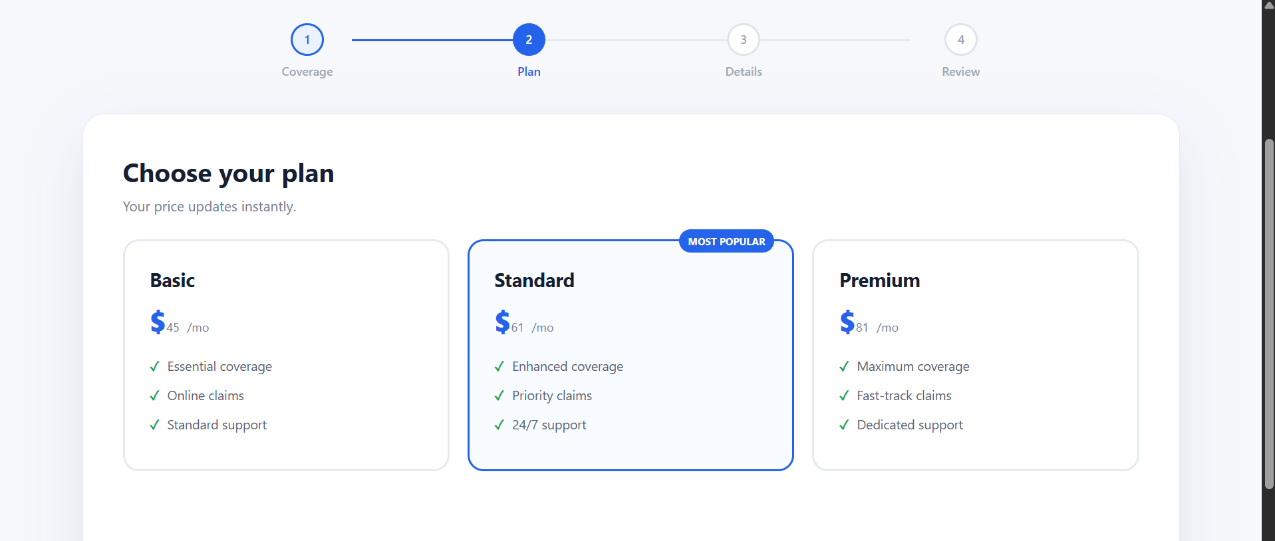

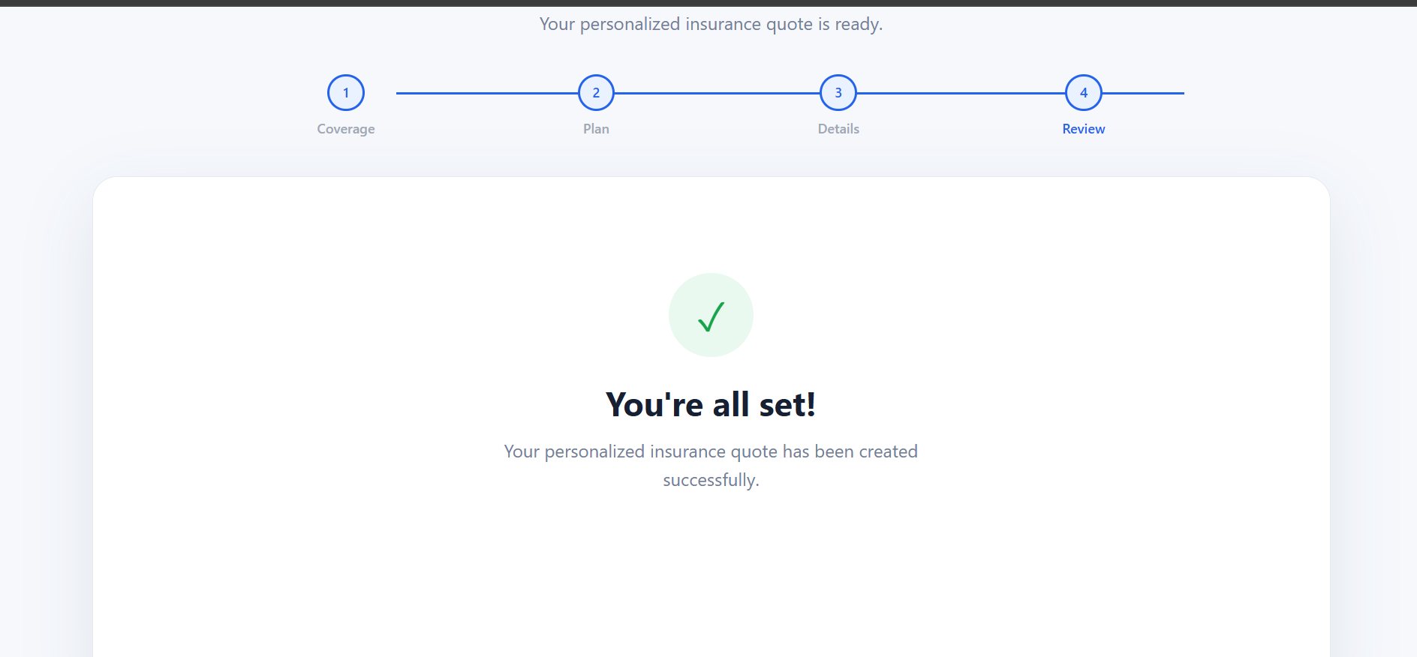

RESULT:
The Hybrid Framework successfully executed automated test cases for the Insurance
Website using a combination of Page Object Model, Data-driven testing, and Keyword-
driven testing.

